**Task on vpc-02.**

========================

1. Create one VPC,with 1 one public subnet and 1 private subnet.

* Open Amazon console and search for VPC
* Open vpc and click on create VPC
* Then select VPC only and provide tag name (eg.My-VPC) and IPV4 block id as IPv4 CIDR manual input
* IPv4 CIDR provide your own CIDR (eg:172.168.0.0/24)
* IPv6 CIDR keep No
* Click on create VPC
* Then will get Unique VPC id
* Now create 2 public and 2 private subnets
* Open VPC in left side section we can fine subnet tab click on that provide the details
* Select vpc id created by you not which existing and provide subnet name(eg:My-pub-subnet1)
* Select availablity zone (eg:now it is in **eu-north-1a select next subnet as 1b)**
* IPv4 VPC CIDR block select which is created by you and
* Provide IPv4 subnet CIDR should be (eg:VPC 172.168.0.0/24 subnet 172.168.0.0/28)
* Click on create subnet

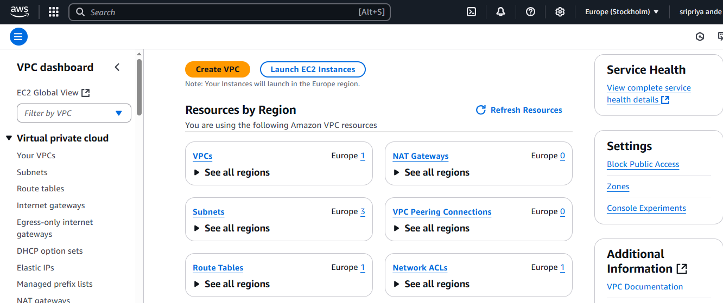

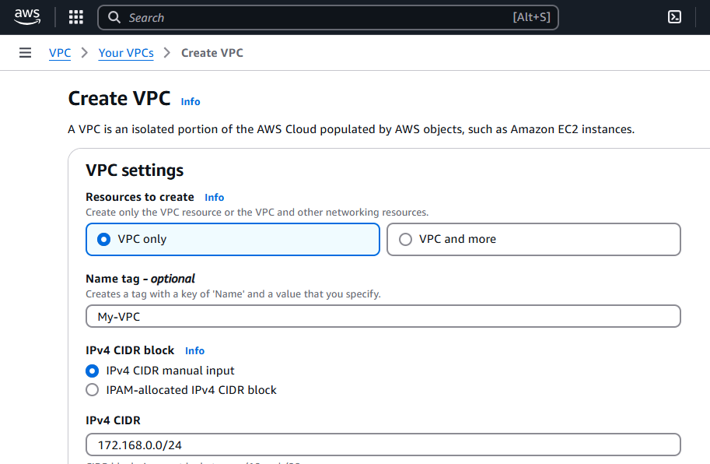

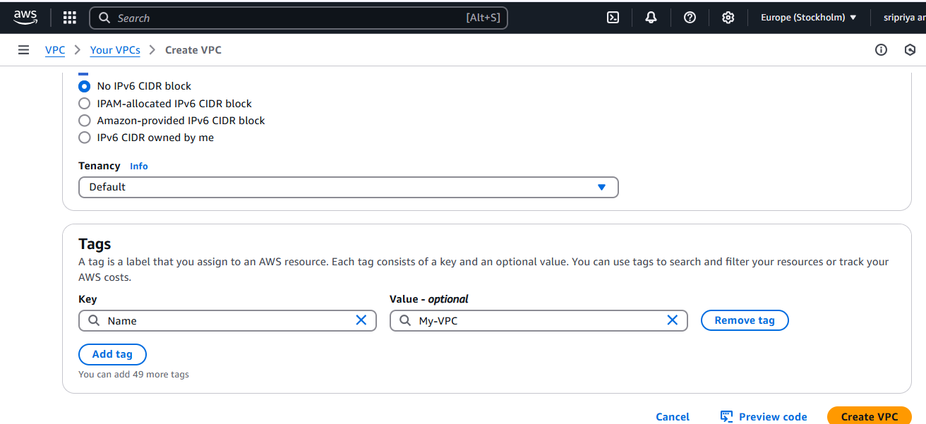

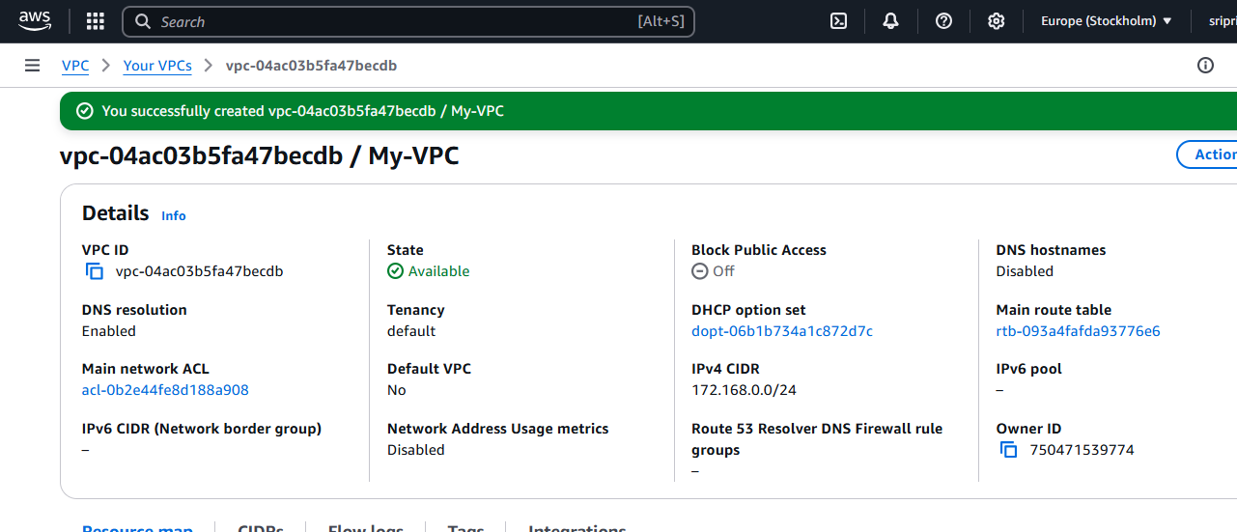

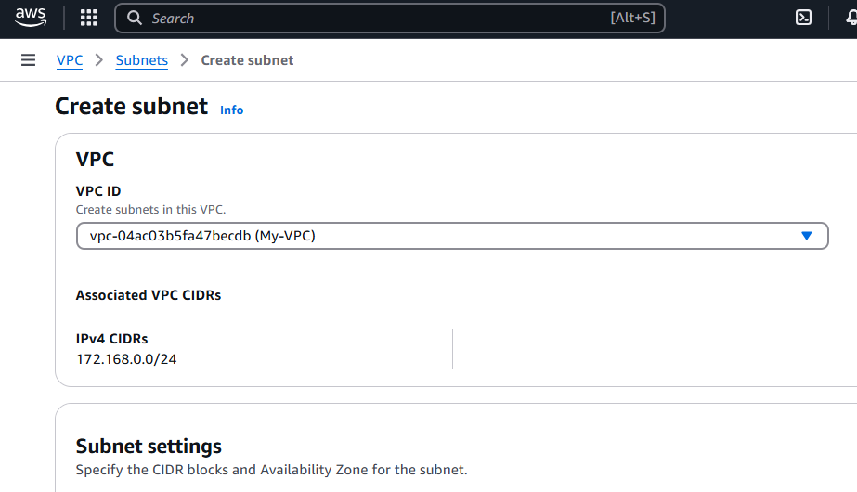

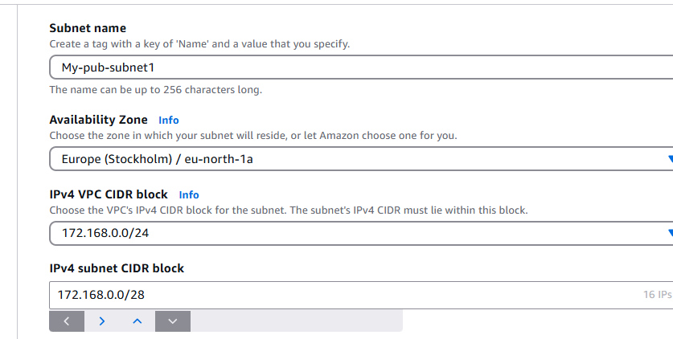

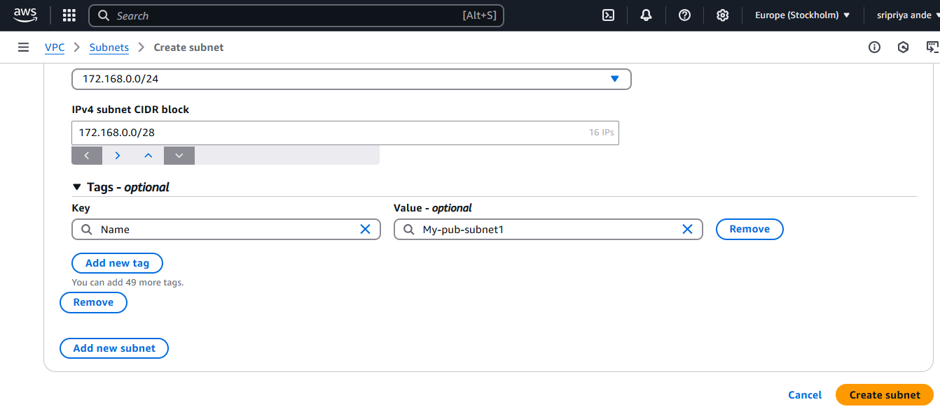

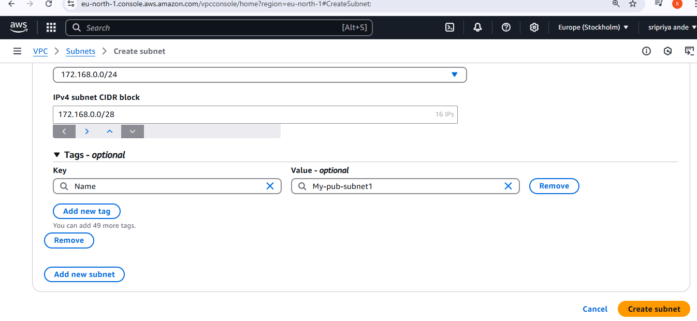

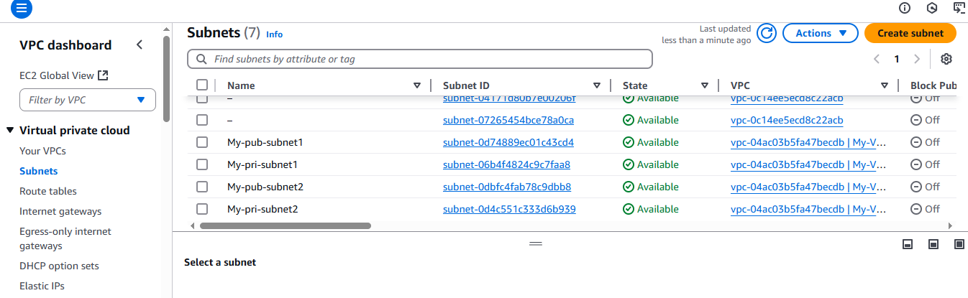

1. Enable VPC peering for cross region.

* To VPC peering we need to create one server in another region ,different account
* Now create on ec2 instance in another region(eg:ohio)
* Using default vpc and create new pem key

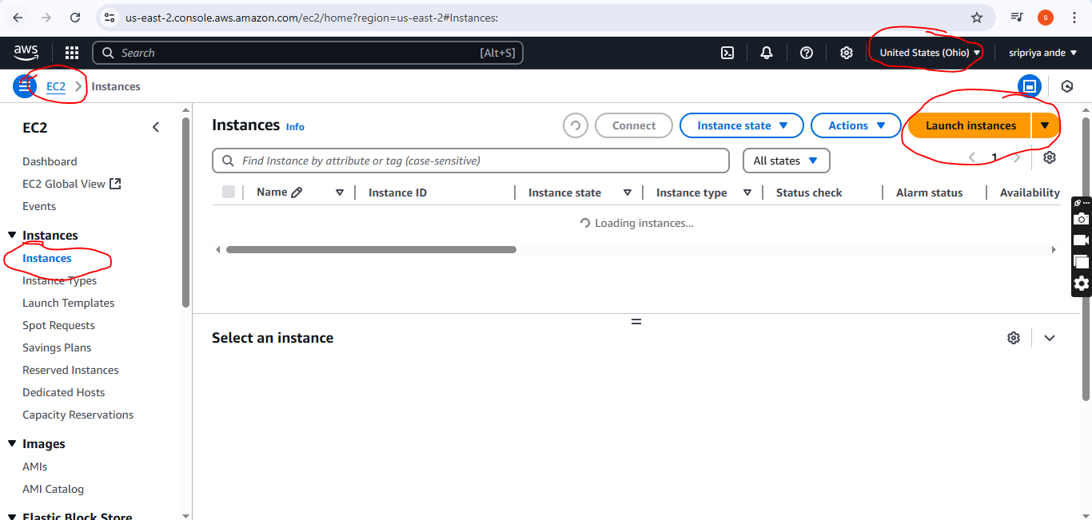

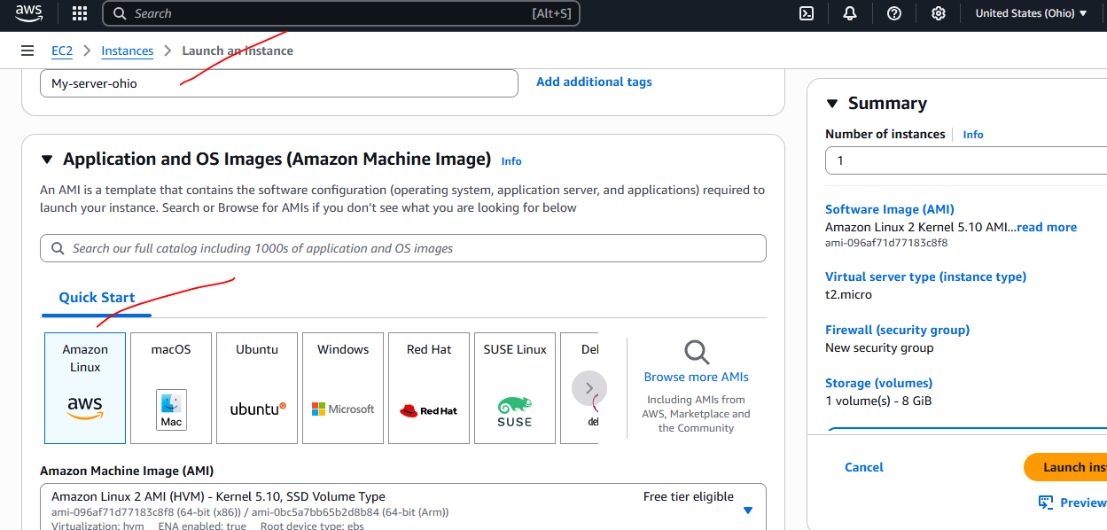

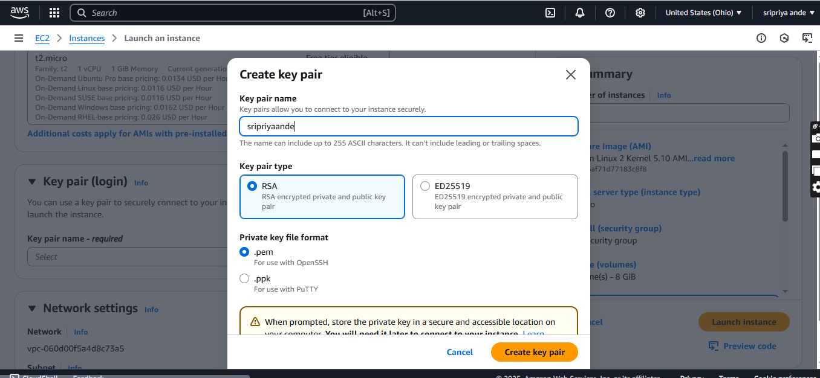

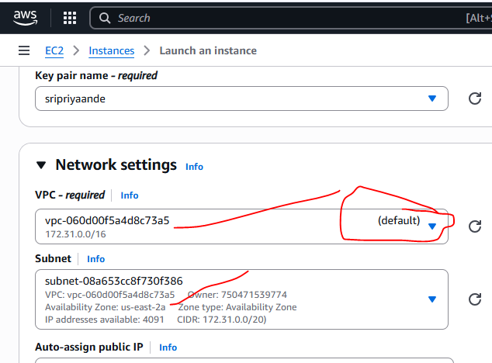

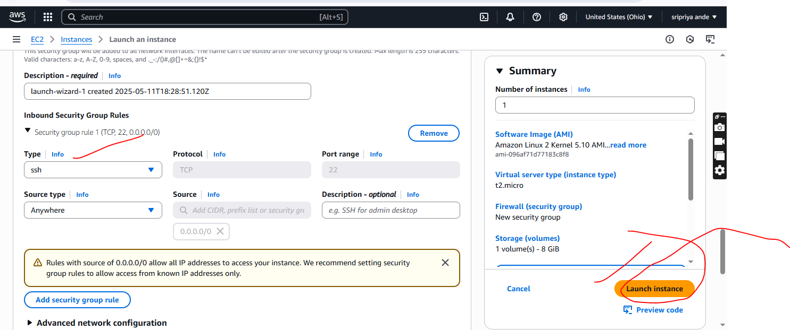

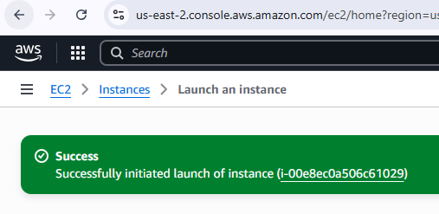

One region public IP and other region private IP

Internet is cnnected

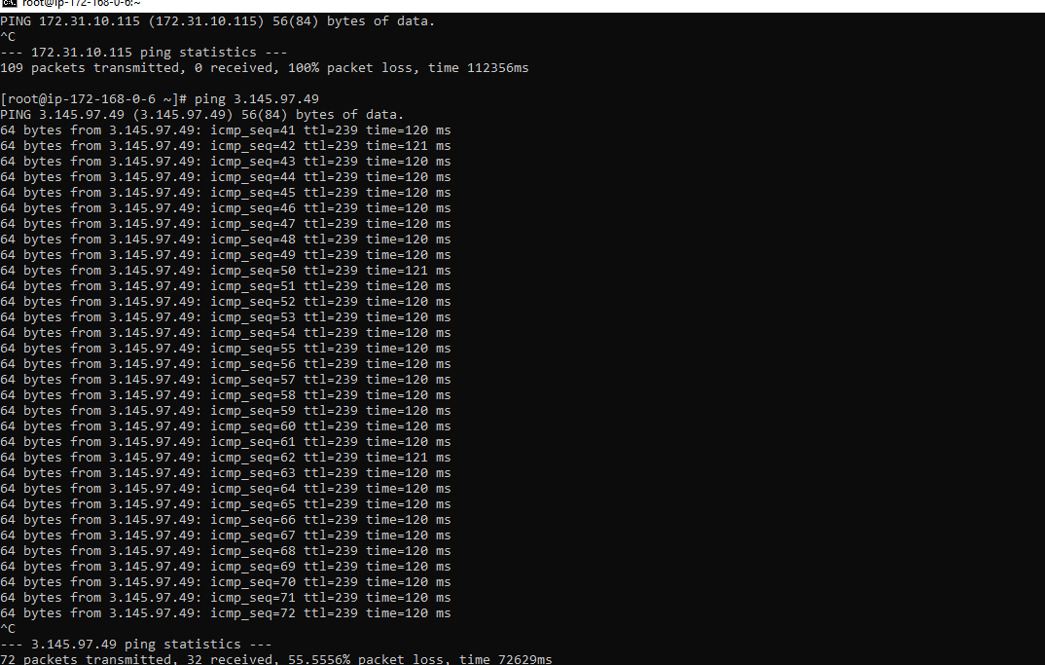

One region public IP and other region private IP

Internet is not cnnected

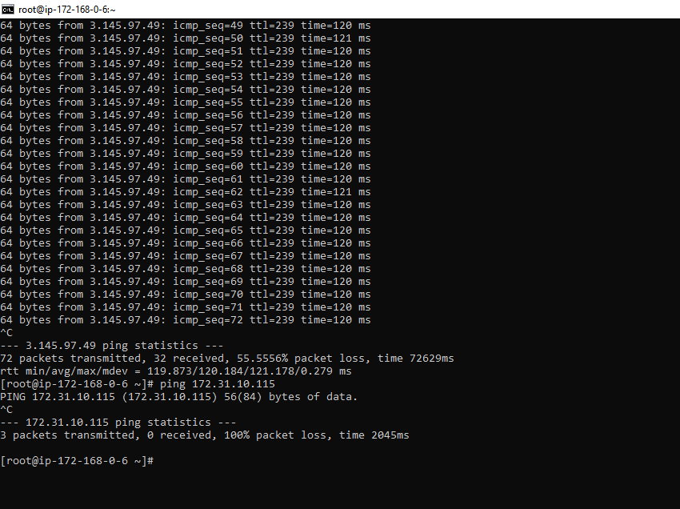

Same region public ip and same region private in another instance connected

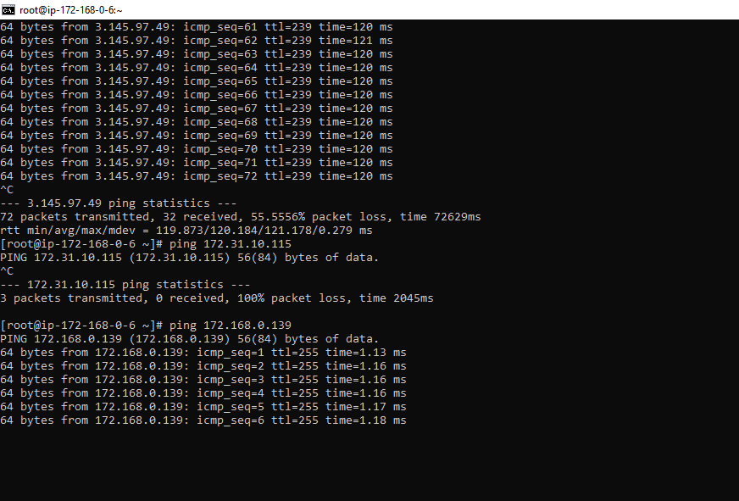

* To peering In one region (eg:europe)in open VPC
* In vpc --->peering connection-->create peering
* Name (eg:peering-europe-ohio)
* Select a local vpc to peer(Myvpc)
* Select another region to peer (my account and region is ohio)
* VPC id of another region or accepter
* Click on create it will pop one message as peering vpc europe to vpc ohio requested
* To peer now we have to accept the request now go to end user(ohio)
* Go to vpc ohio
* Click on peering connection
* You can see penidng acceptance
* Select and click on action
* You can find acceptrequest
* Click on that
* Then acceptance establishes the connection
* Now go to VPC(europe)---->route table --->publicRT-->edit route
* Add route(add cIDR range of ohio copy from ohio)
* Peering connection-->select peering id---->save chnages
* Similary go to another region vpc(ohio)
* VPC(ohio)---->route table --->publicRT-->edit route
* Add route(add cIDR range of europe copy from europe)
* Target Peering connection-->select peering id---->save chnages
* Now go to bash ,here connect with Europe public ec2
* Ping private<private ip>(ohio)
* Connected sucessfully
* 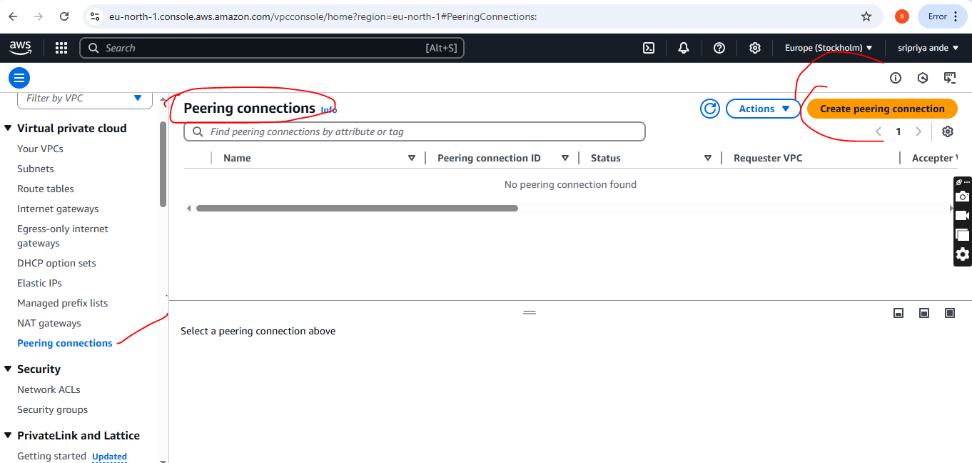

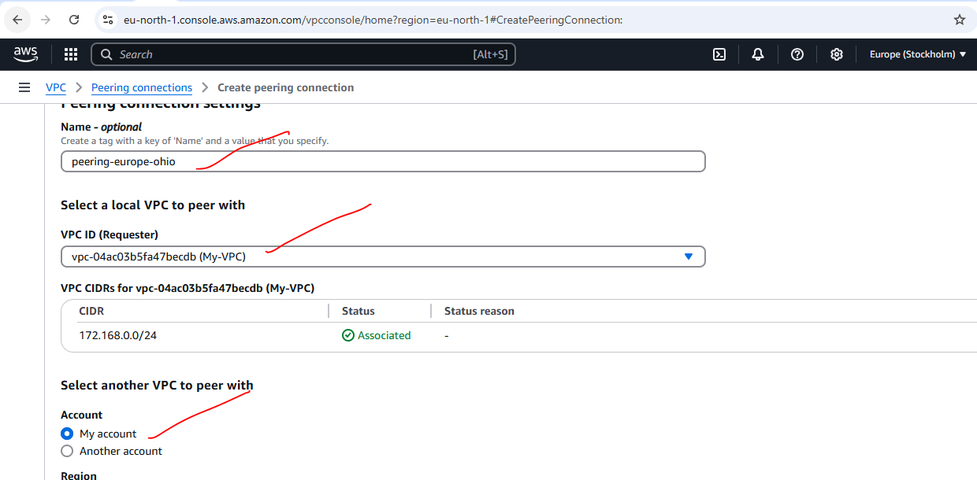

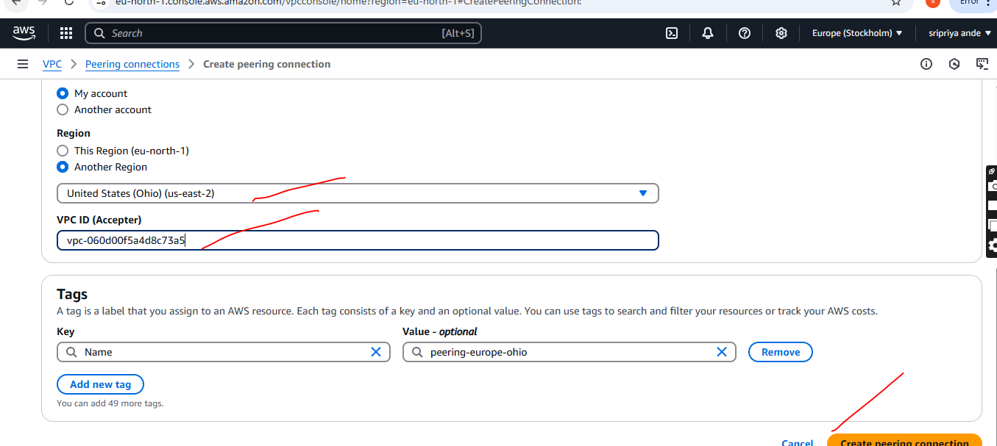

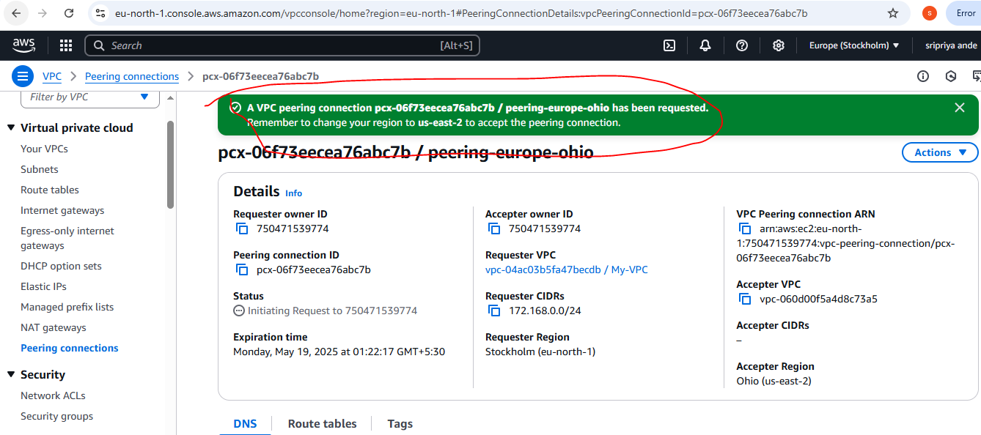

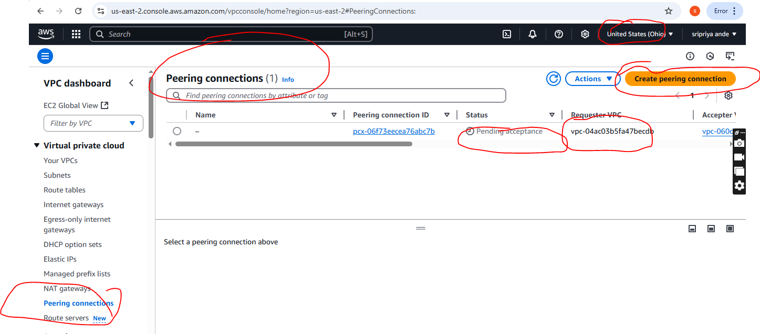

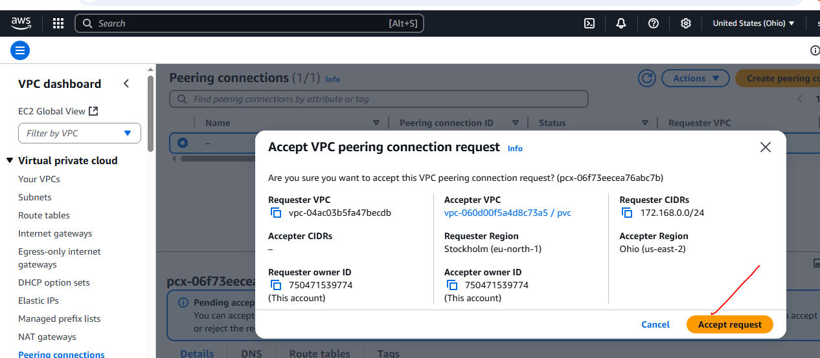

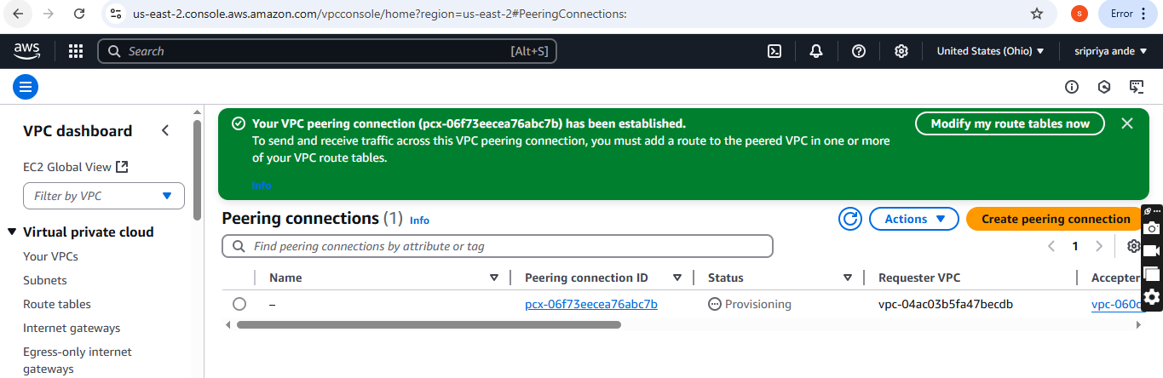

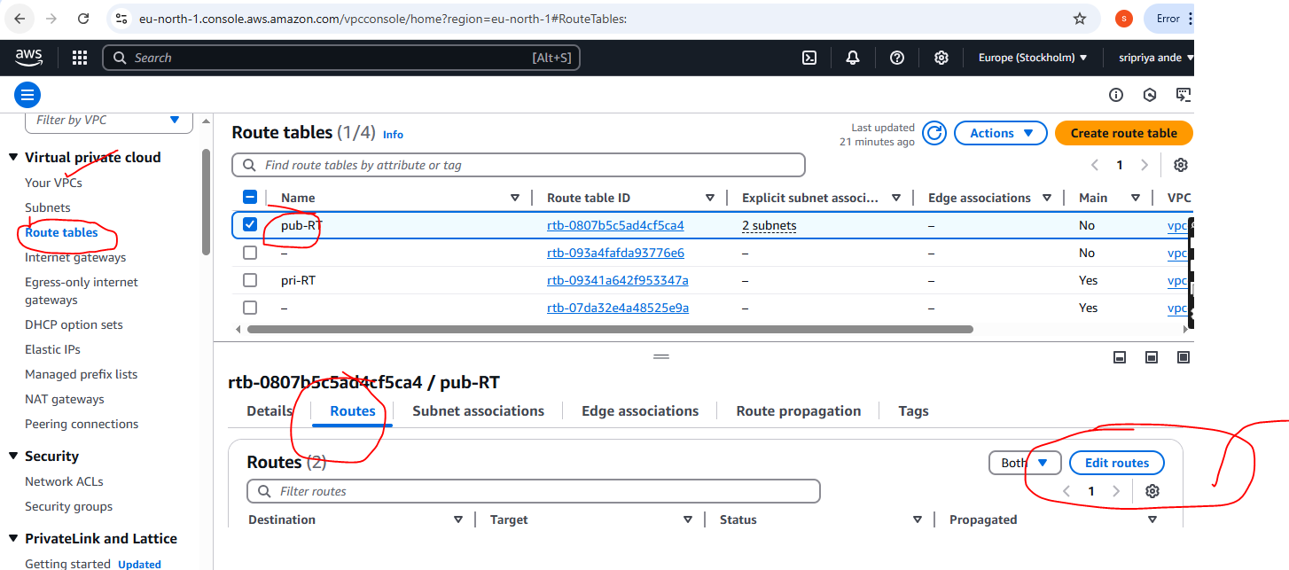

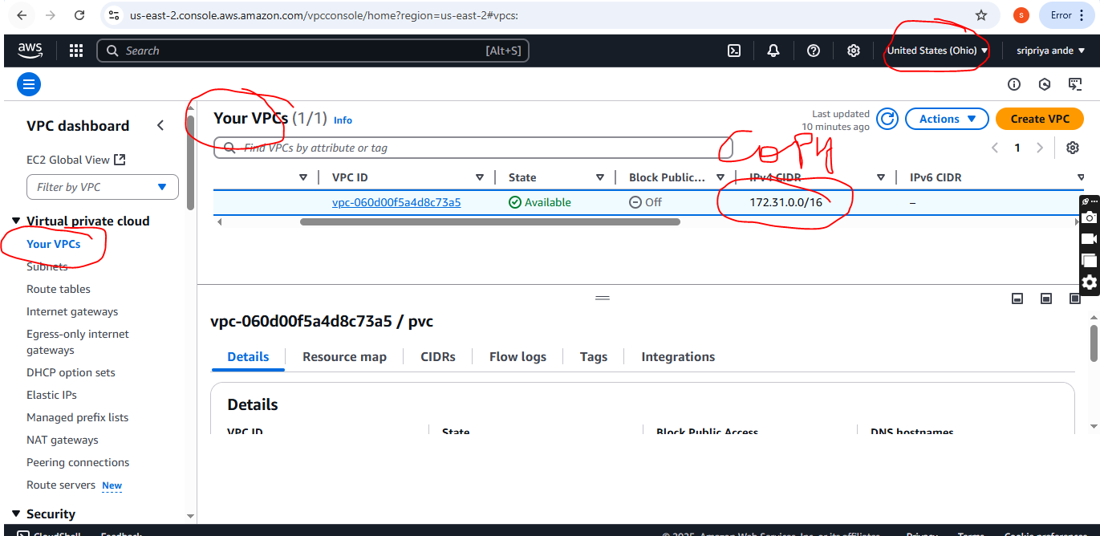

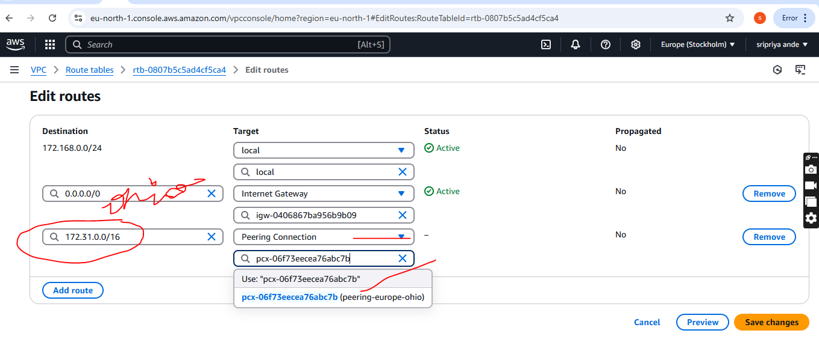

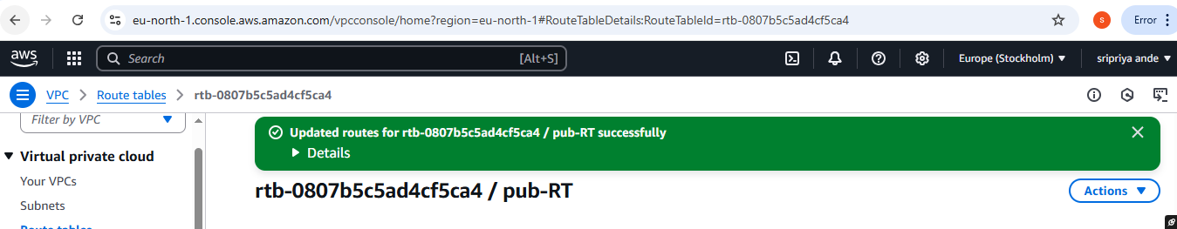

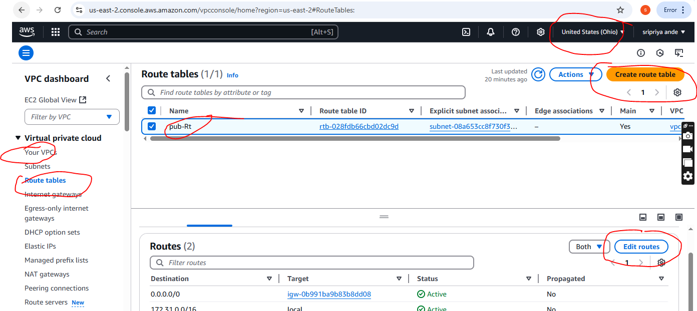

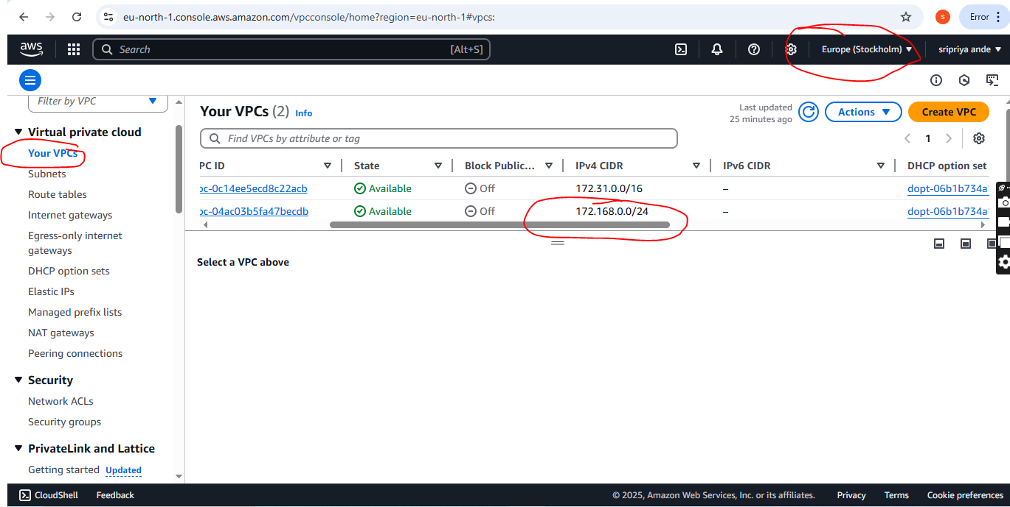

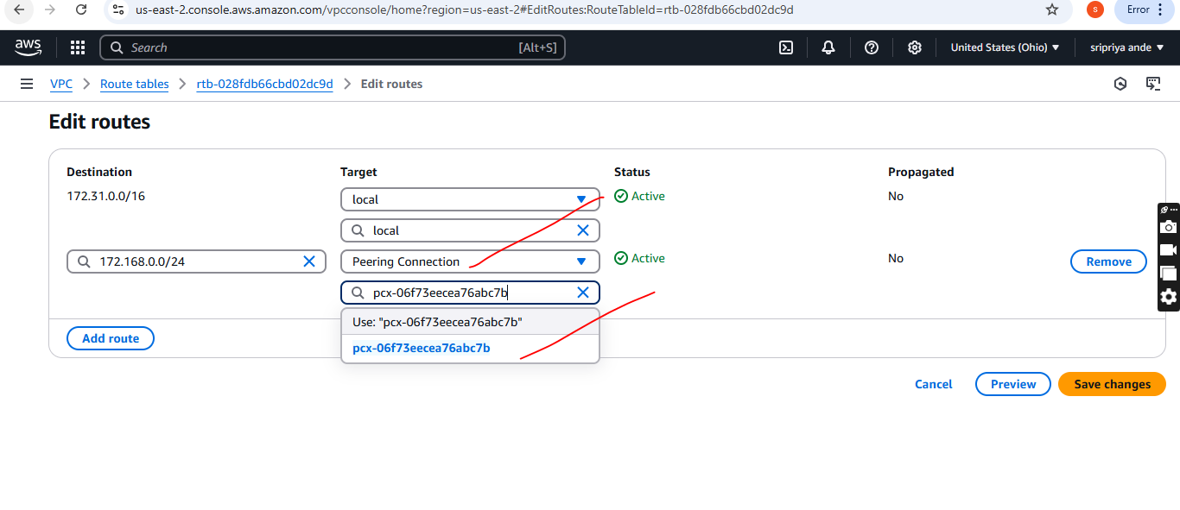

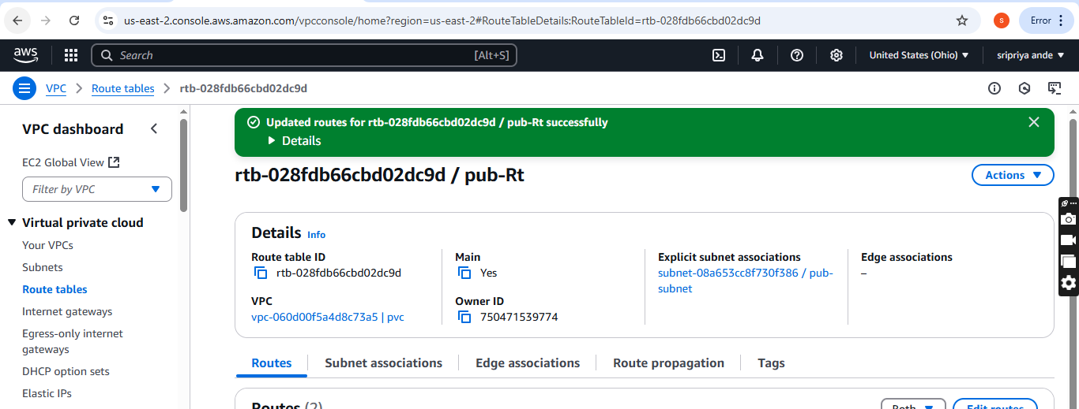

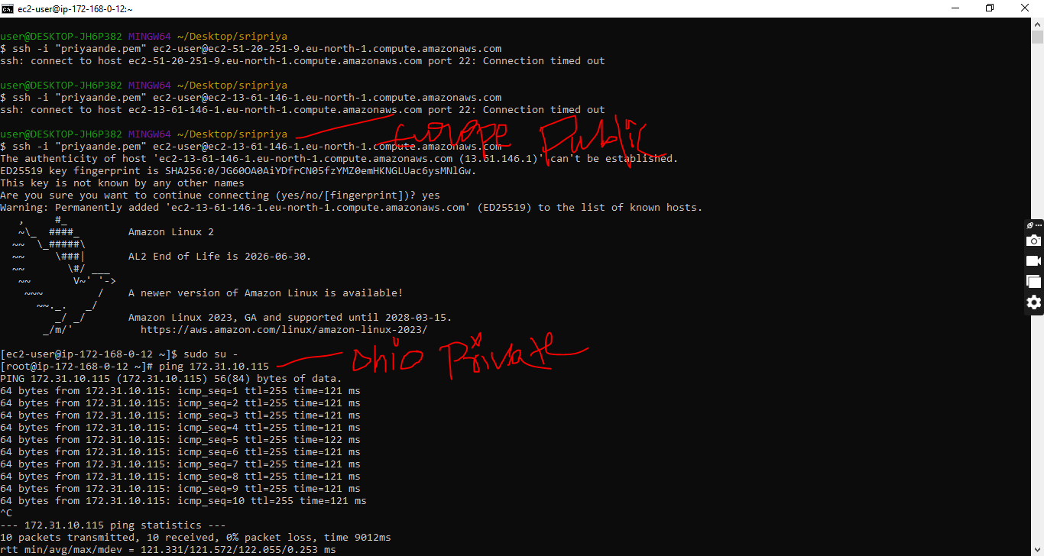

1. Enable VPC peering for cross account. (You can collaborate with your friend and do this task).

* Create one vpc with 2 subnets(private and public)with CIDR
* Attach one subnet with IGW
* Then create route table and associte with subnets (public in Pub-RT and private in private RT)
* Then set public as main
* Go to VPC peering and provide tag name ,rquester vpc ID,another account ,another account region,accepter vpc and click create
* Accepter received request and accept the request
* Then provides private Ip address of ec2 in instances
* In this account will create one ec2 instance and set security groups
* All traffic and ssh
* Go to git bash and connect with ssh and the ping <private ip of another account>

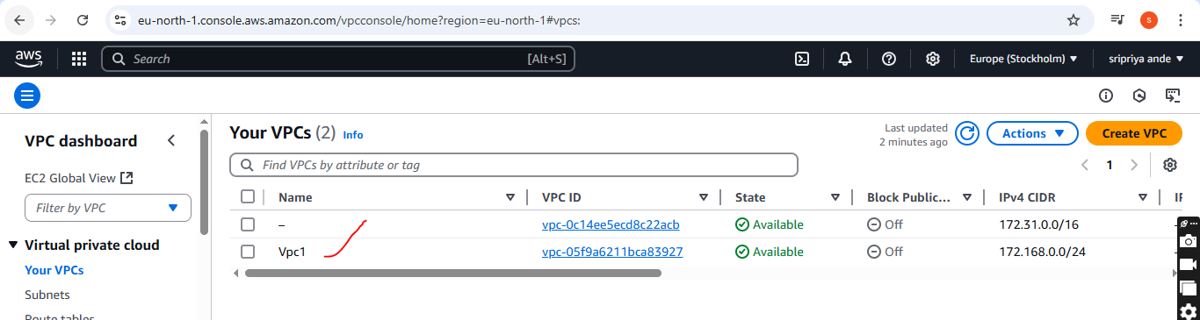

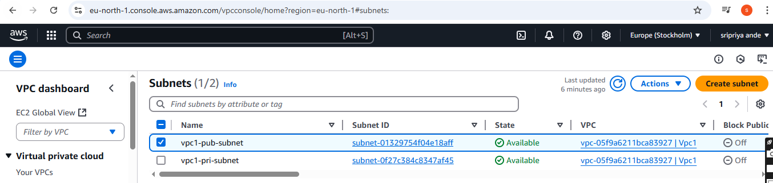

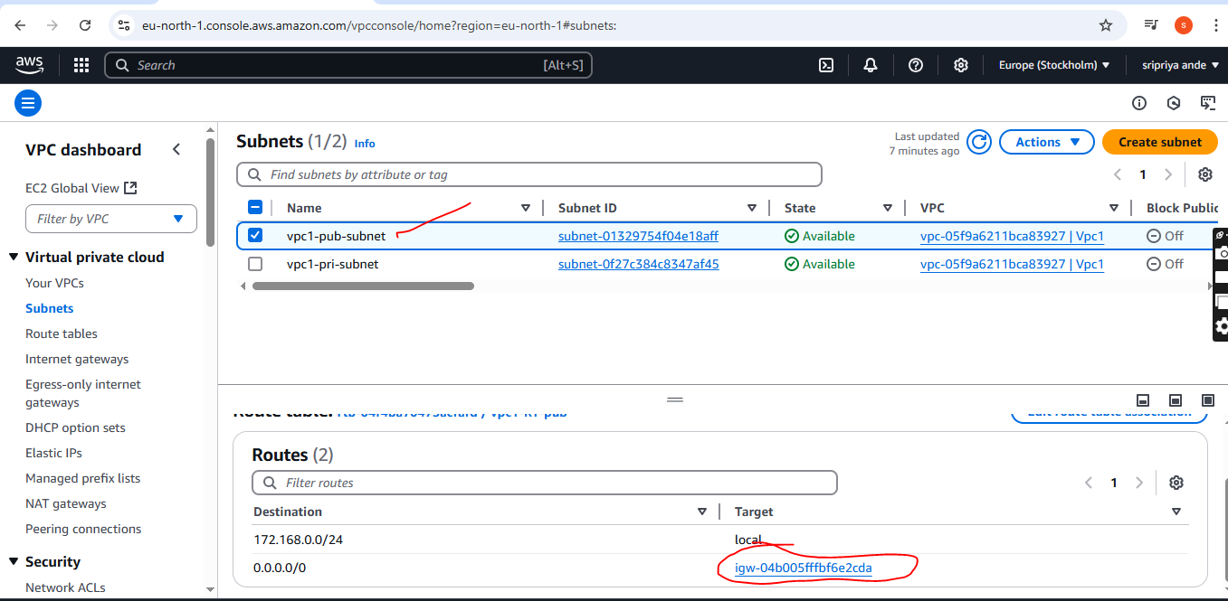

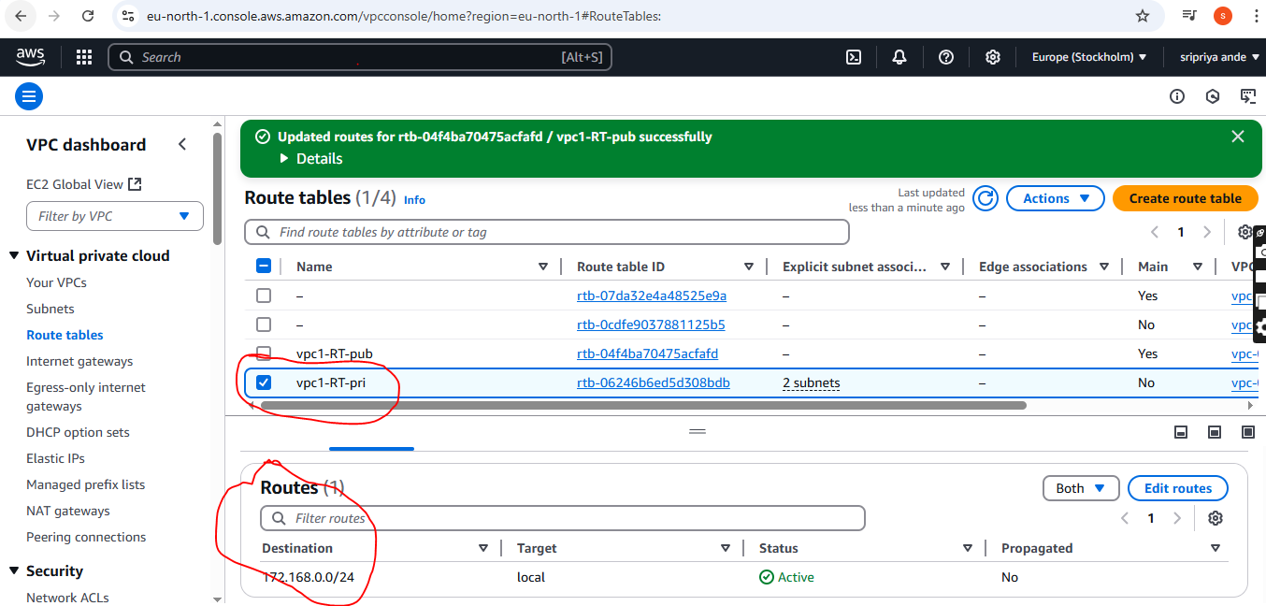

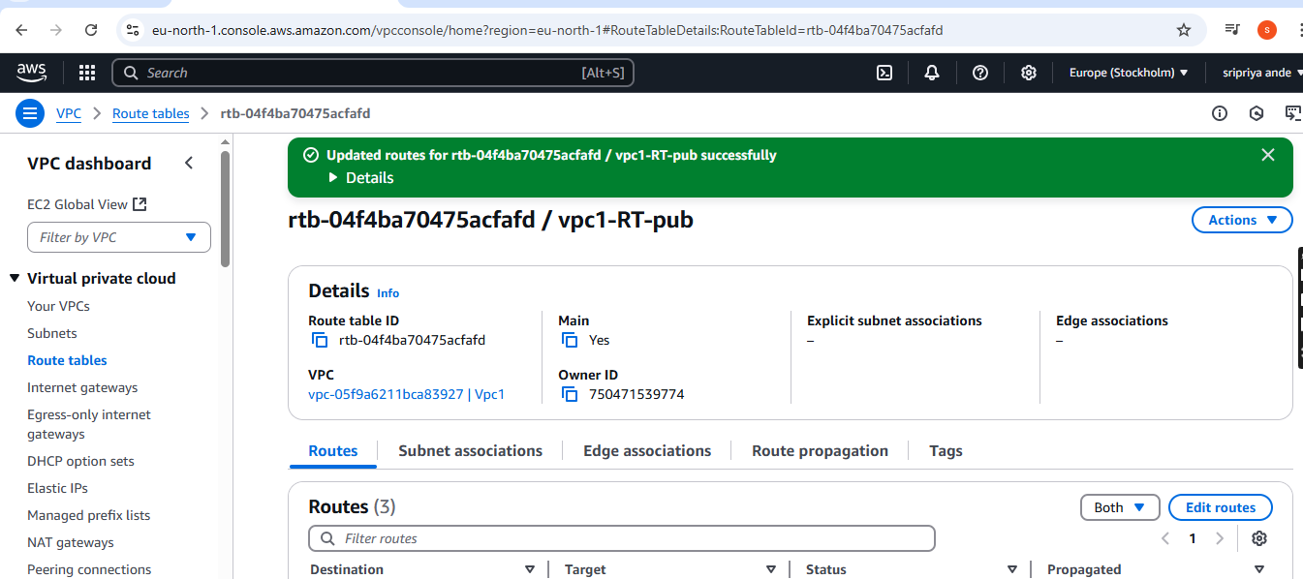

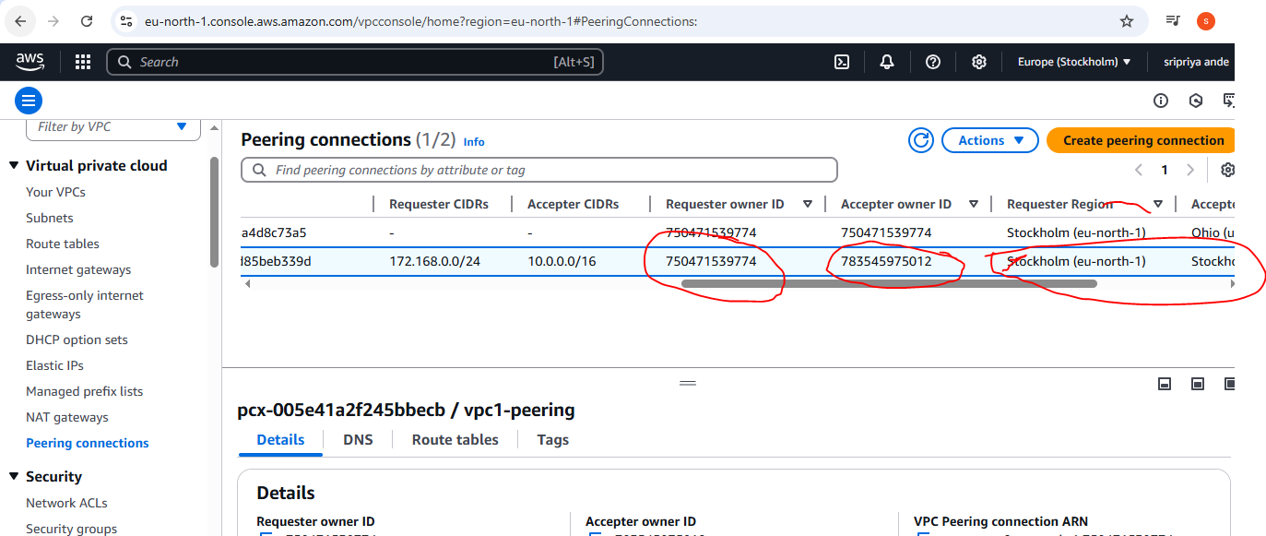

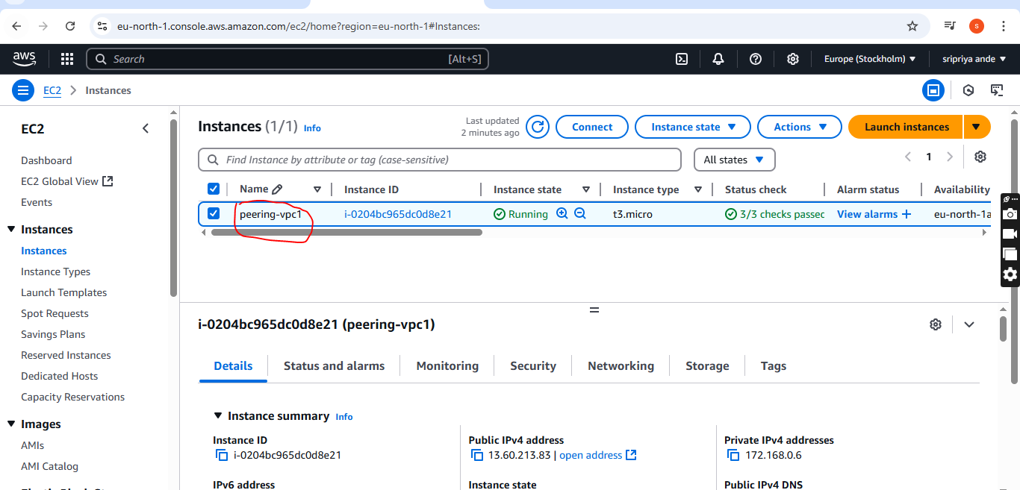

**Another account**

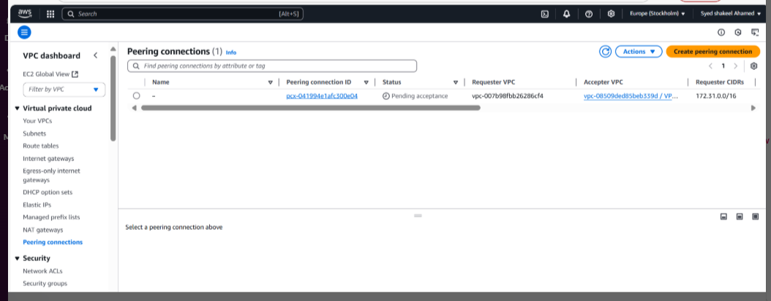

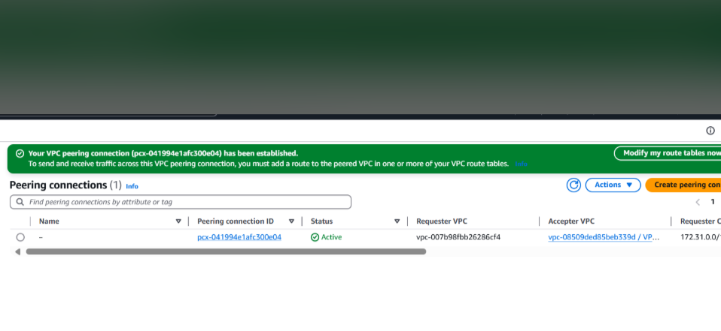

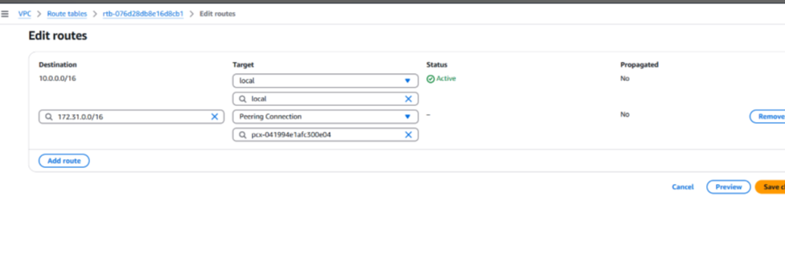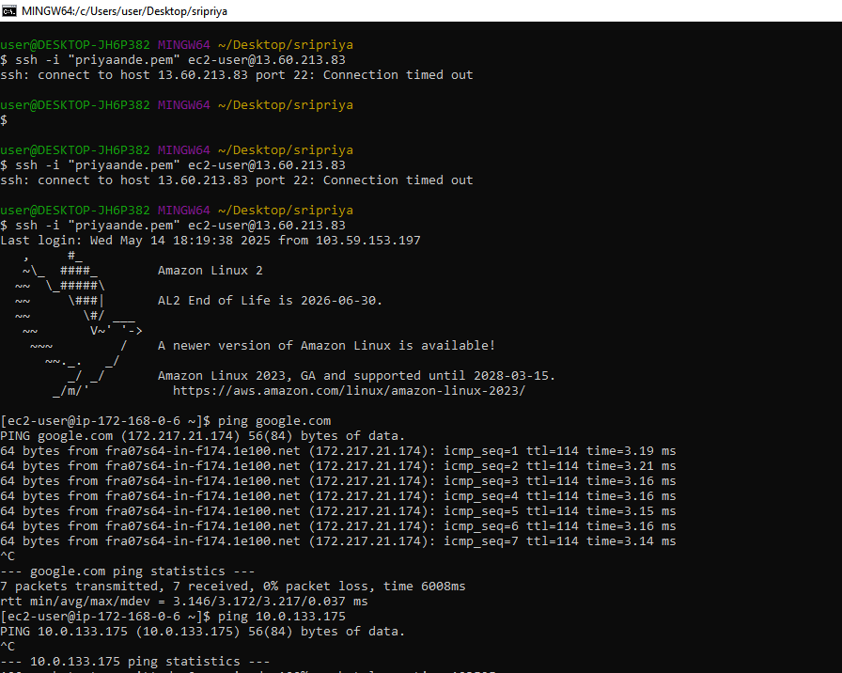

1. Setup VPC Transist gateway.

* Go to VPC and create 4 vpc’s with CIDR
* Vpc1 with 172.168.0.0/24 and one public subnet with 172.168.0.0/24
* Vpc2 with 10.0.0.0/28 and one private subnet with 10.0.0.0/28
* Vpc3 with 10.0.1.0/28 and one private subnet with 10.0.1.0/28
* Vpc4 with 10.0.2.0/28 and one private subnet with 10.0.2.0/28
* Now go to transit gateway provide name tag,ASN as default,enable everything and click on create(TG will not ask for any vpc or subnets)
* Now click on Transit gateway attachment and click on create Transit gateway attachment provide name tag,transit gateway id,attach type(eg:vpc)
* VPC1 id then click on create
* Similarly,create attchment for all the VPC’s 2,3,and 4
* After creating TG attachment it will by default create TG route table by default
* Do not make any changes in TG RT
* Go to transit gateway Route table and create one route table click on check box in association we can see vp’s added
* Now go to routes they are automaticlly created
* Now launch 4 ec2 instance with 4vpc and login to public ec2 vpc1 and ping with vpc2 ec2instance private id (no internet access)
* Because all the request whivh have been redirecting to these vpc’s we haven't mentioned our vpc where this traffic need to be redirected.
* We know that we have Tc created which is help us to distribute with subnet and all
* But our vpc this request has been redirected to our vpc routing tab;le and our routing table is not aware where this traffic need to be sent.
* Now go to RT click on vpc1-RT
* Edit routes and add routes copy vpc 2,vpc3,vpc4 CIDR and paste ,then select Tg and TG id ---->save
* Similarly do this to all Rt
* Now Go to git bash and try to ping (still it is not connected)
* In vpc1 internet gate way attched and noe create IGW all the vpc’s
* Similarly connect all the vpc’s to IGW --->create IGW for all the vpc’s
* Go to add--->IGW all the RT
* Check security group to all the instance (all traffic--->save)
* Now check vpc1 with vpc2,vpc3,vpc4 (private ip)
* Similarly check vpc2 with vpc3,vpc4and vpc1
* Check vpc3 with vpc1,2,4
* Check vpc4 with vpc1,2,3
* All these are communicate

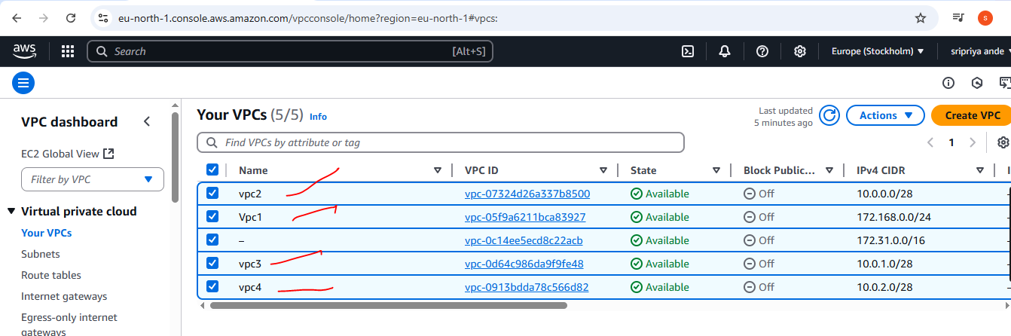

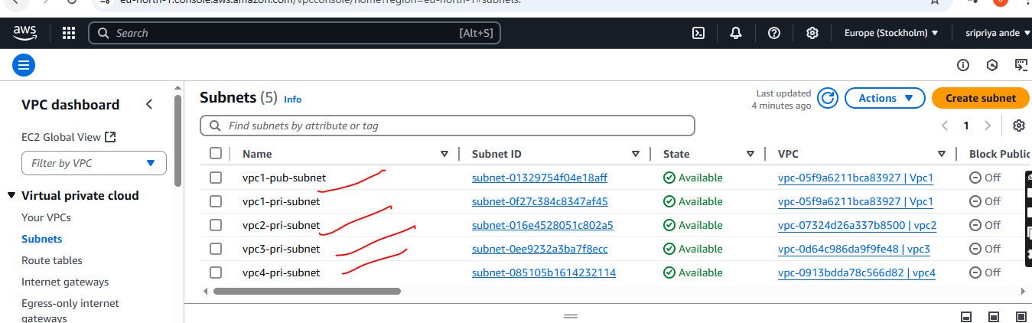

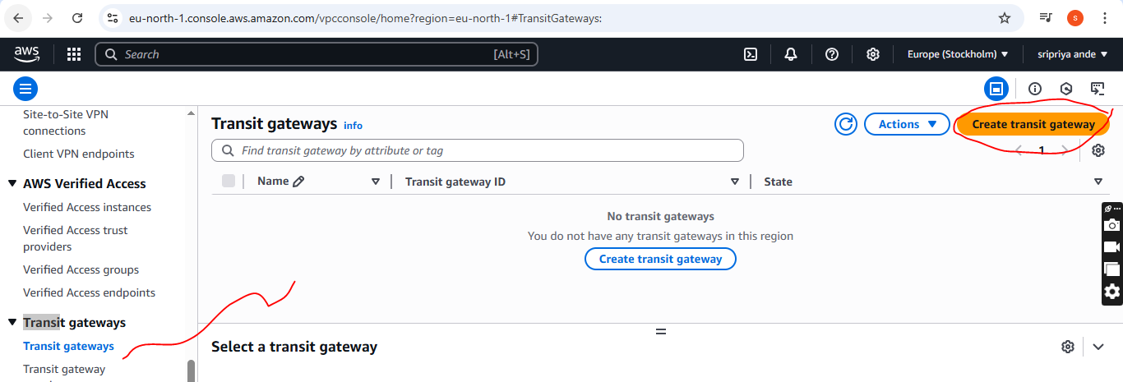

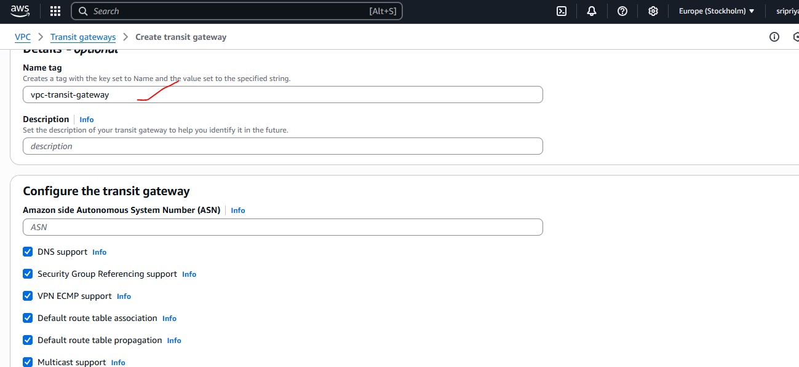

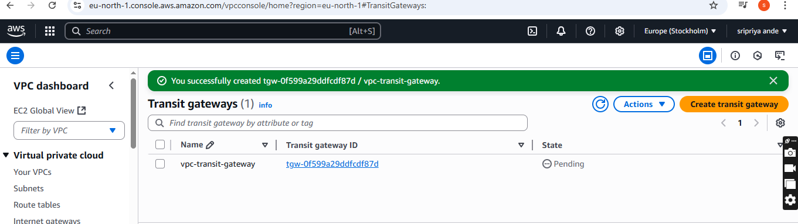

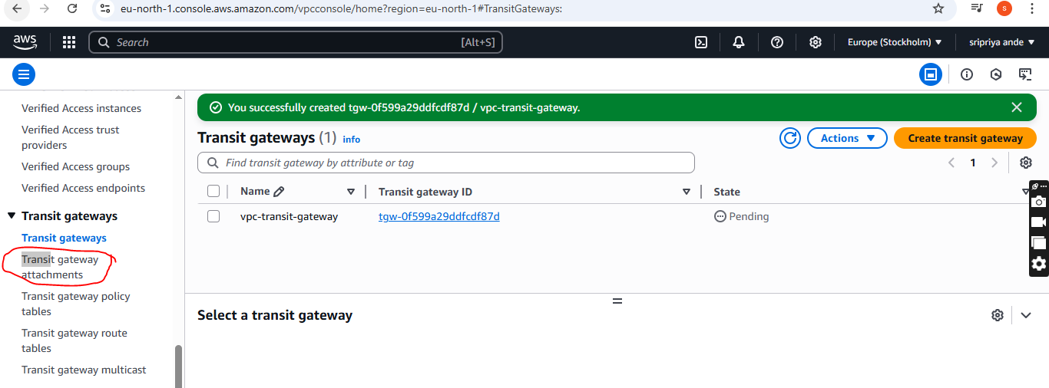

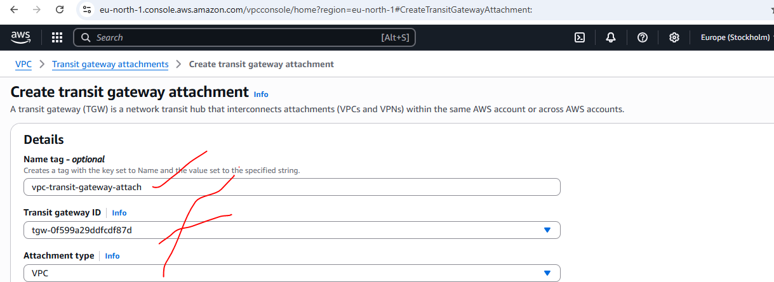

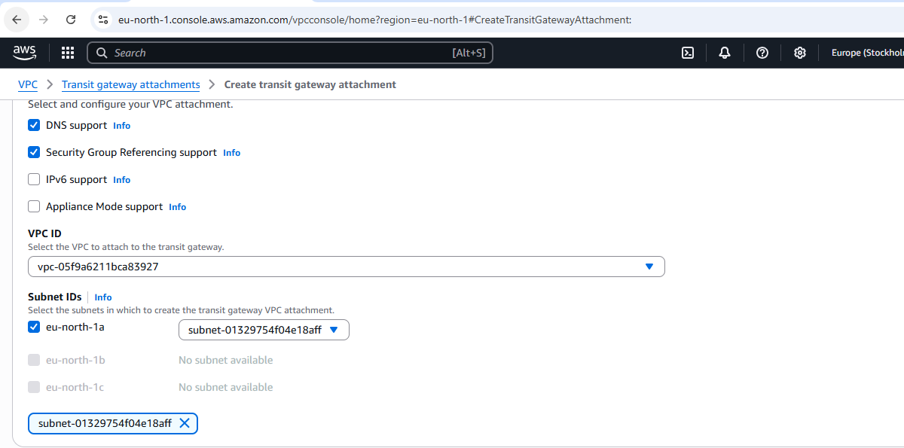

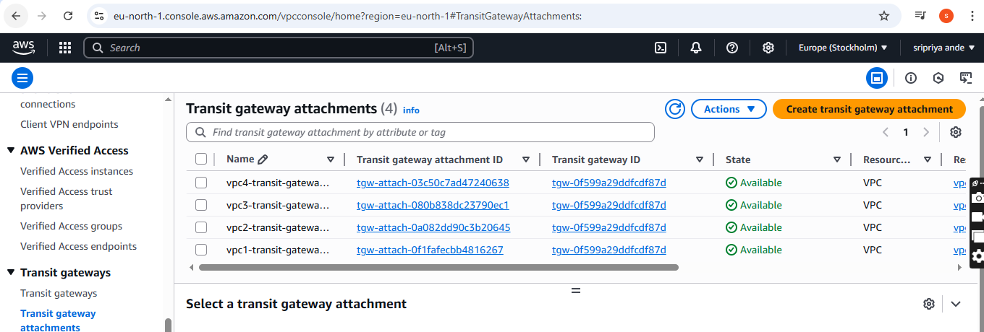

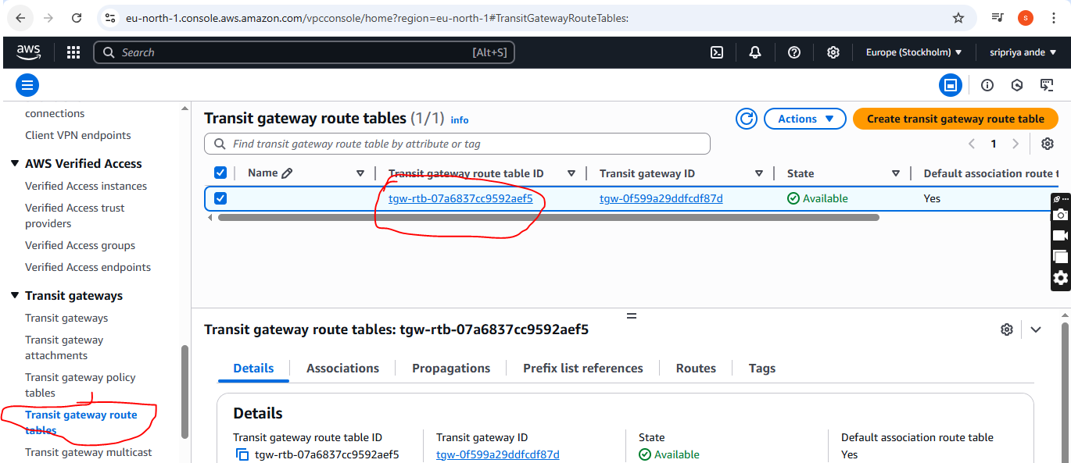

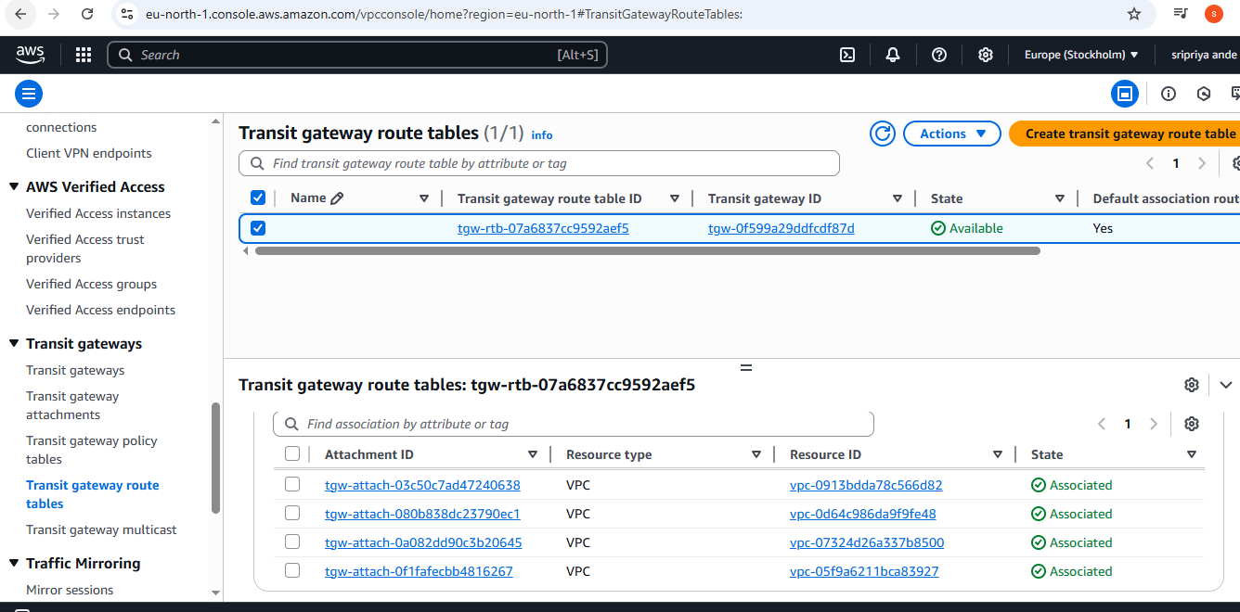

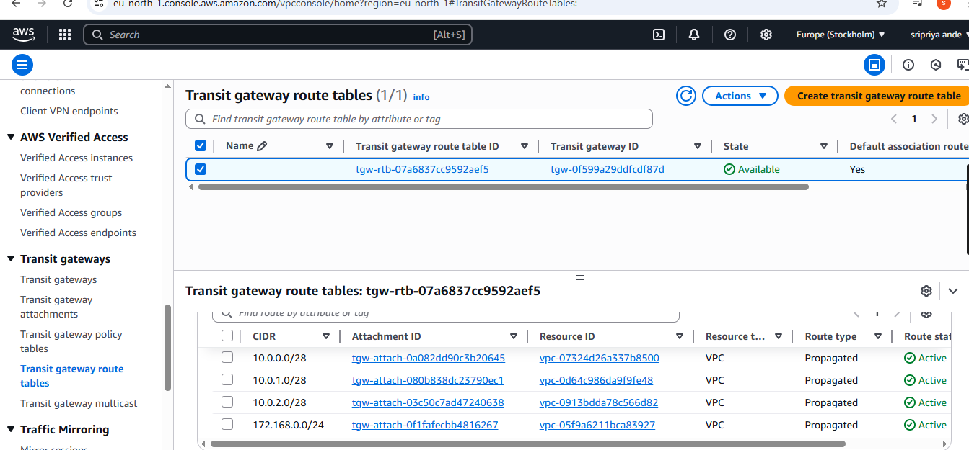

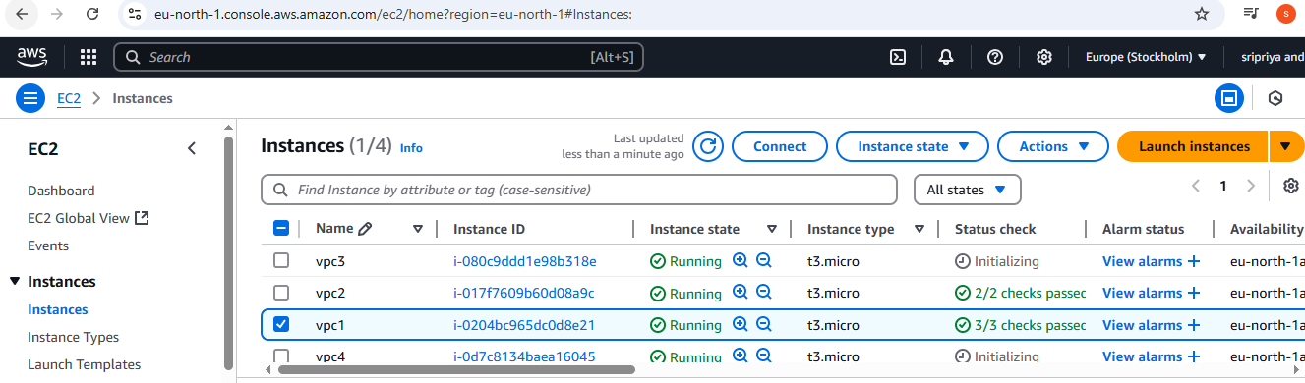

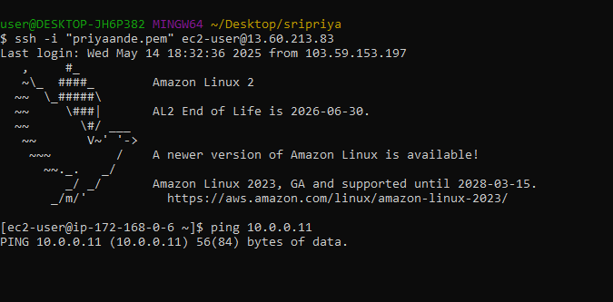

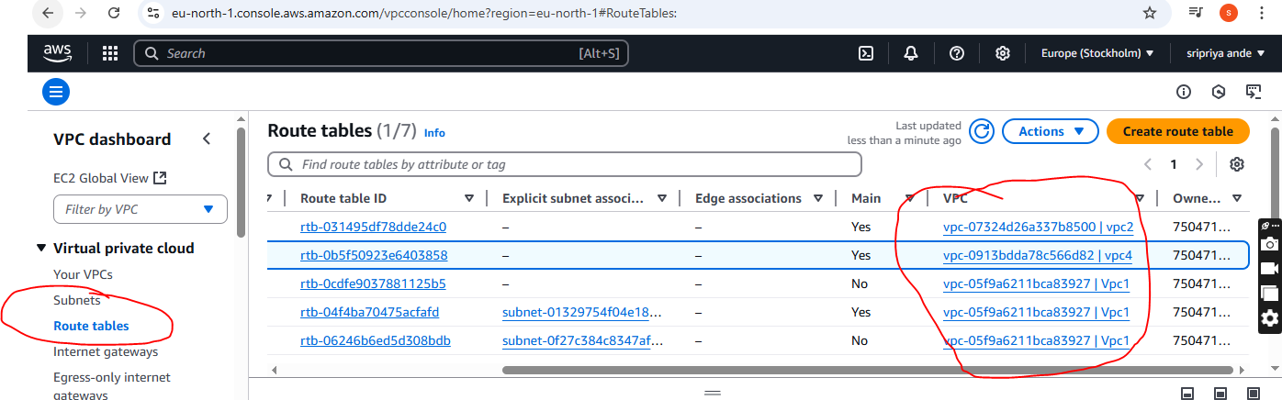

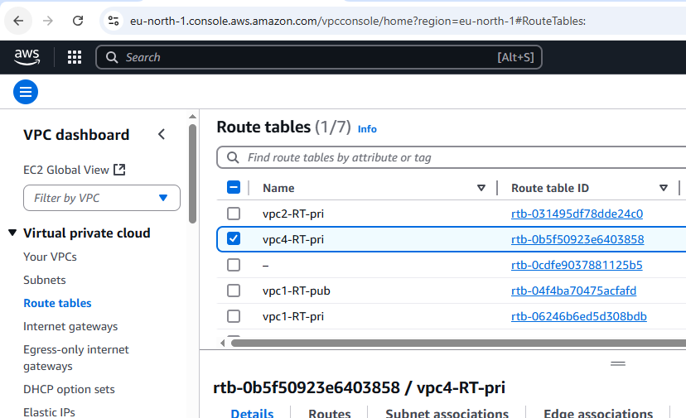

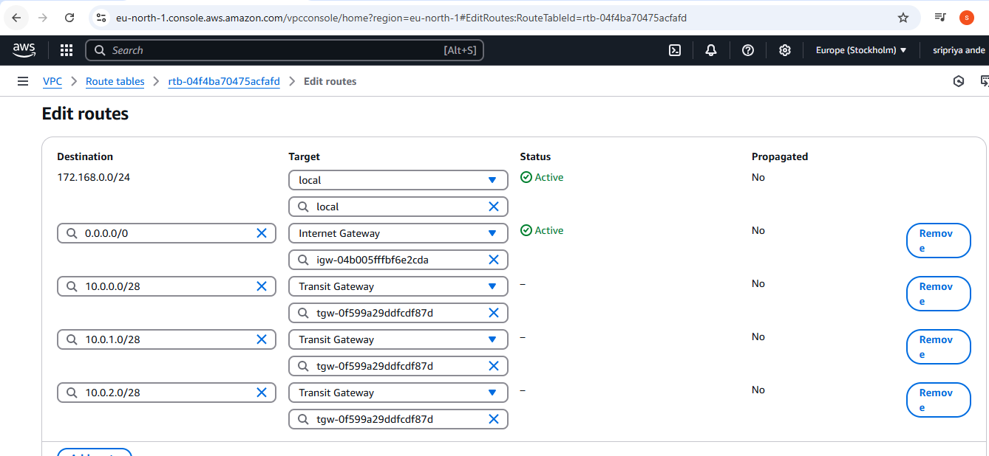

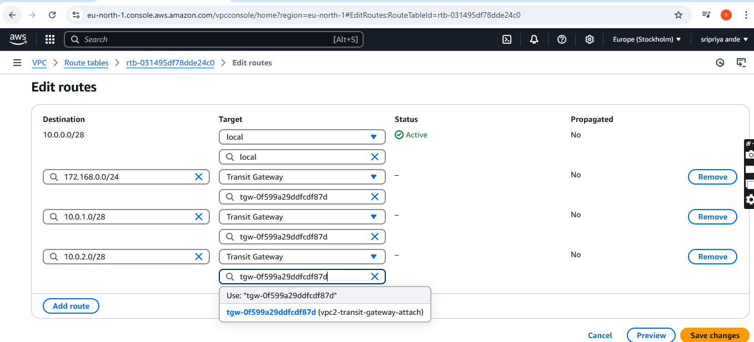

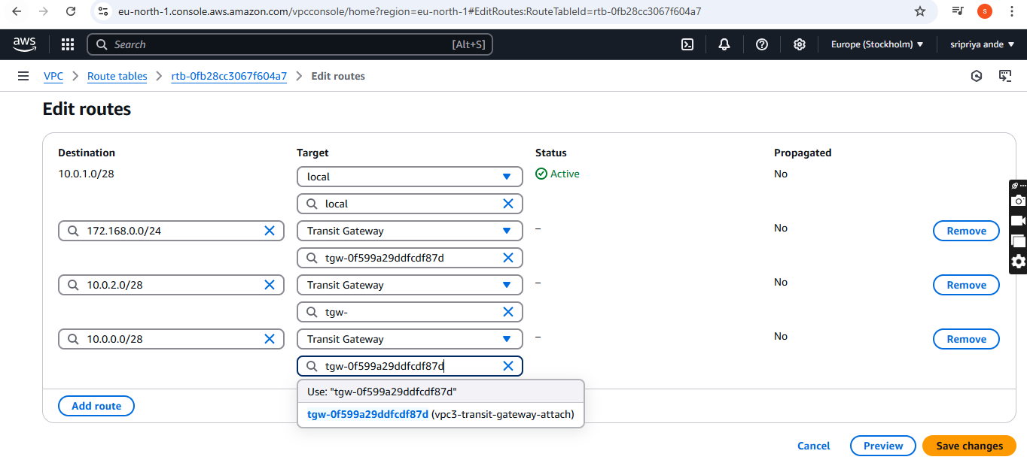

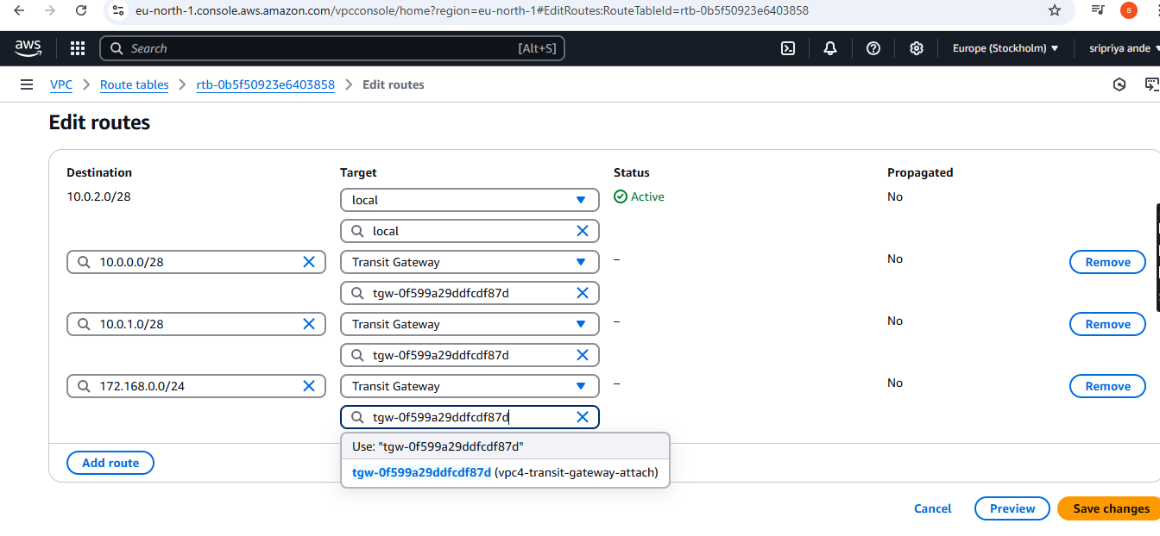

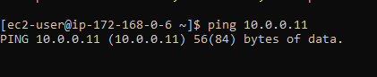

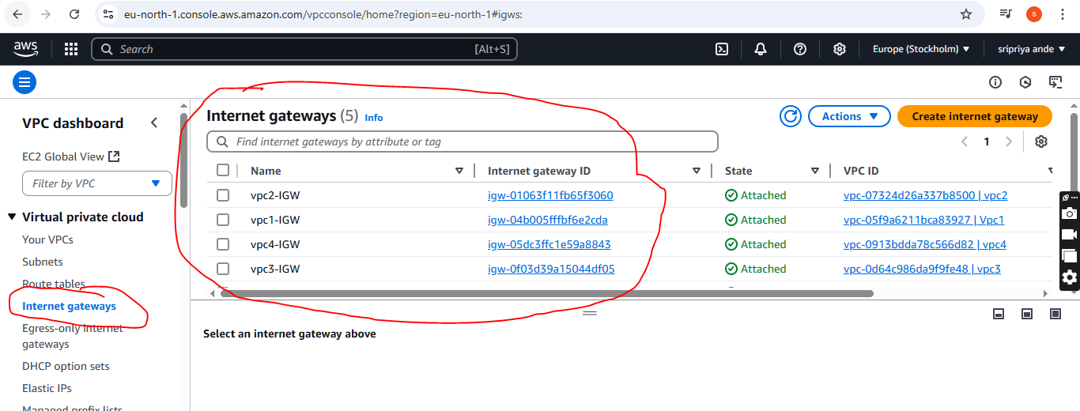

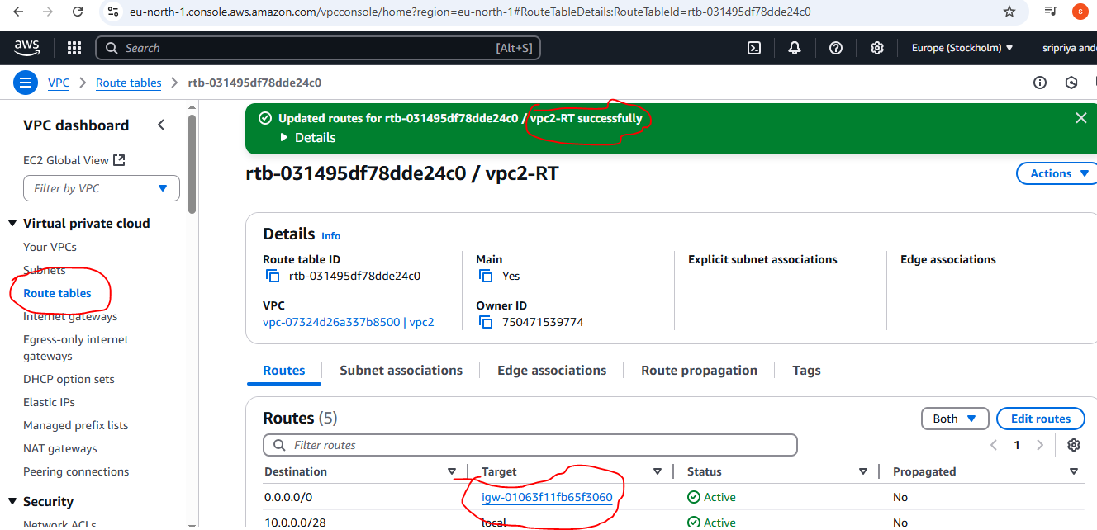

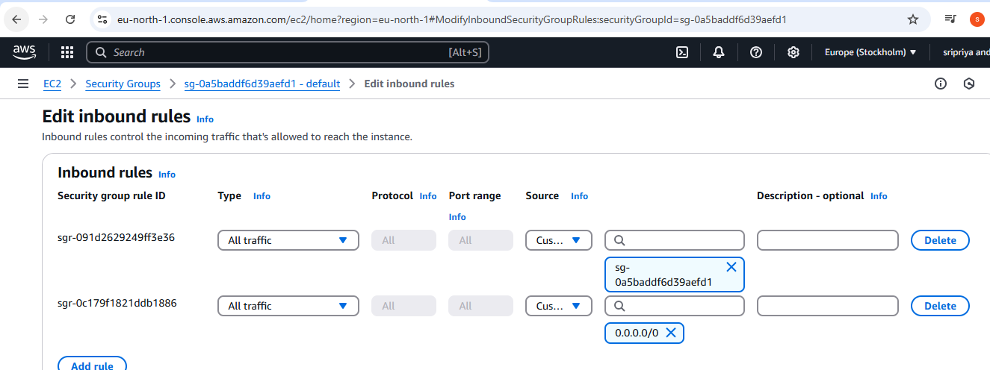

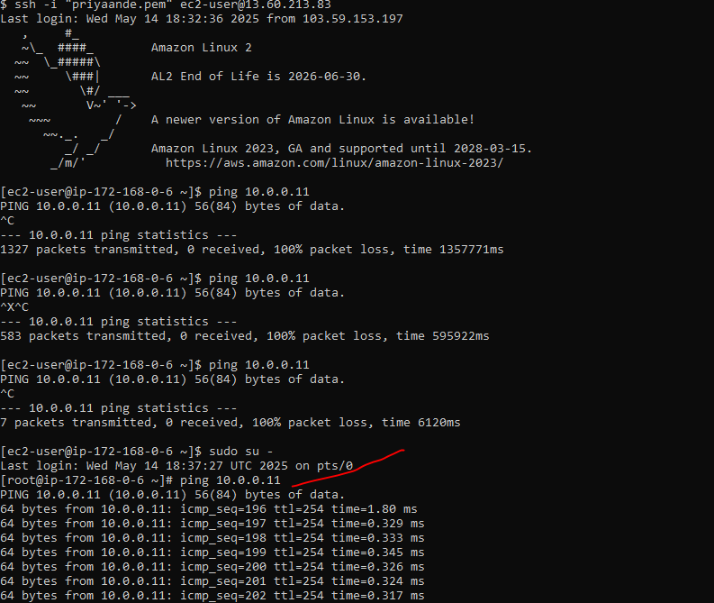

1. Setup VPC End Point.

* **Go to** AWS console
* Open VPC ---->go vpc--->click on subnet---->take on pub-subnet and private -subnet
* Launch 2 instaces in ec2 with pubnet (enable) and private with (disable)
* Now create S3 bucket ,Search S3 qnd use existing one
* Go to ec2 public ec2 and connect to bash after connecting
* Aws s3 ls(for public ec2 if it is not configured then configure)
* Aws configure
* Access key and security key provide Go to security crendentials in ec2
* Aws s3 ls
* We can access the bucket
* Now we want to connect with private IP
* **In**  in publich ec2 create file with pem key anf provide chmod 400 permission
* Then connect to ec2(jump server)
* Search foe aws s3 ls
* It will not give any output because it is not connected to internet so **now creating end pint for this s3**

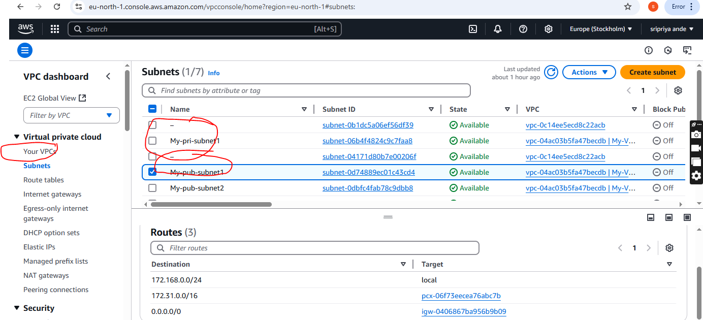

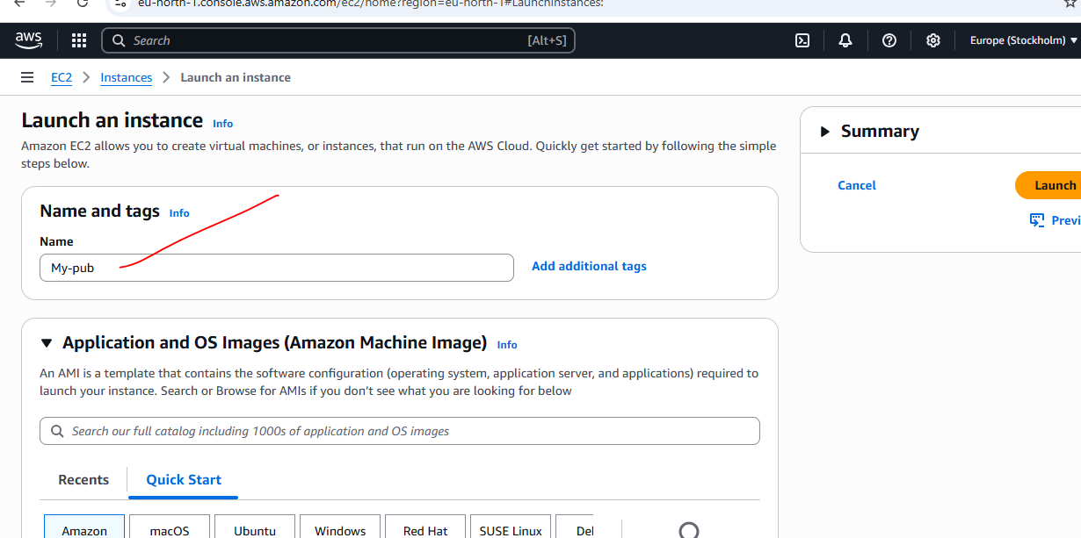

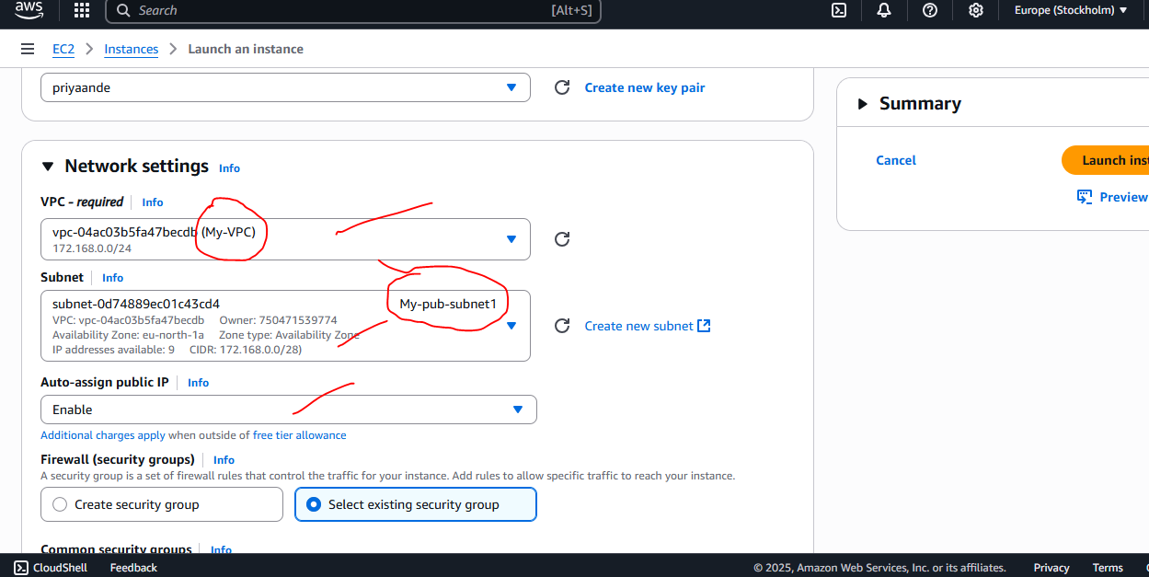

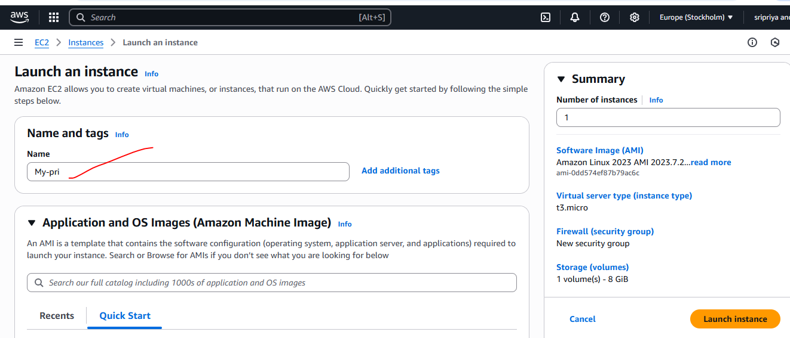

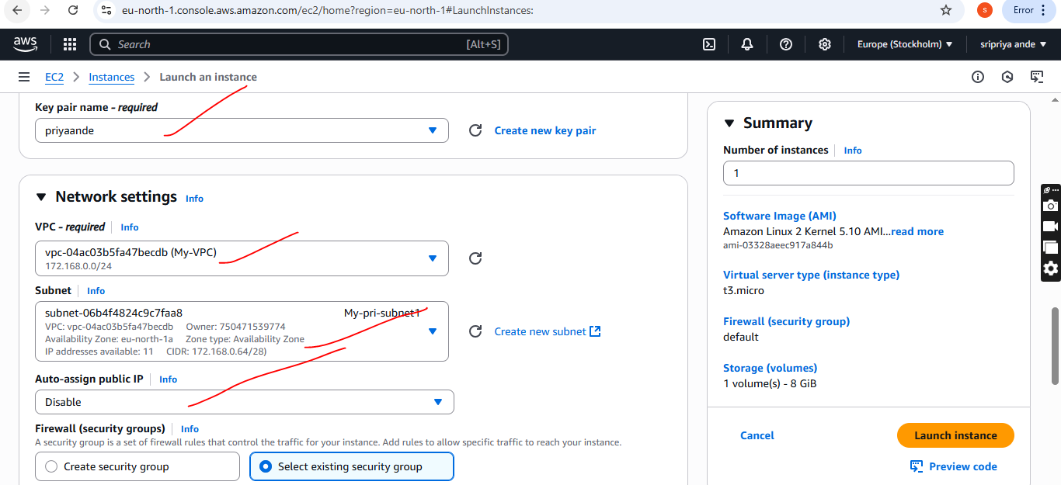

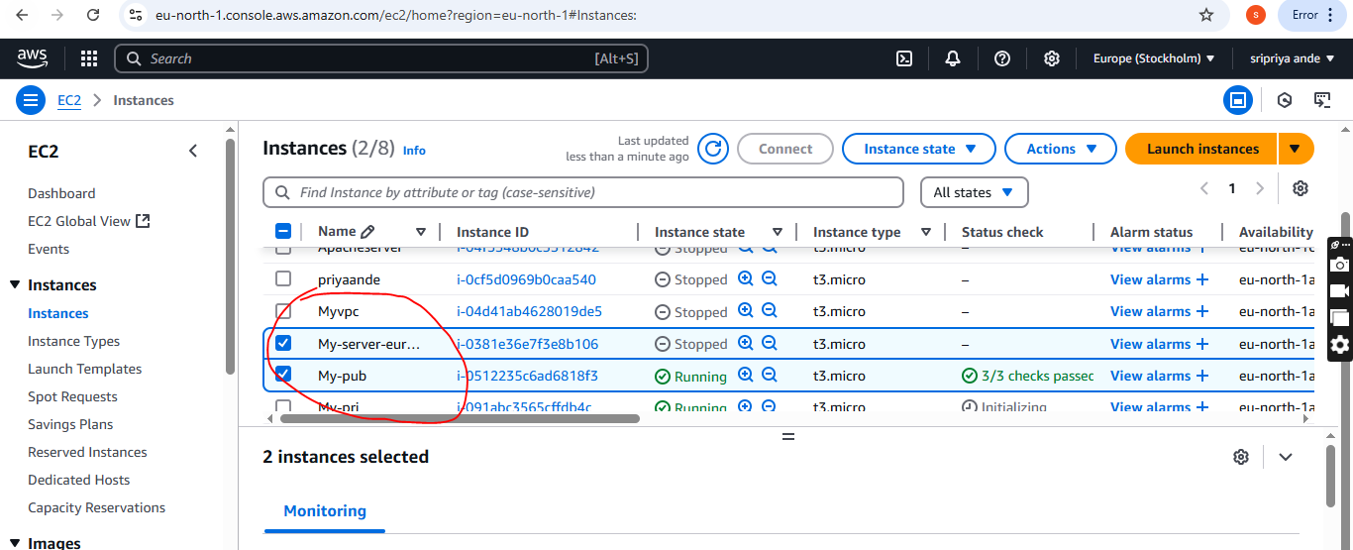

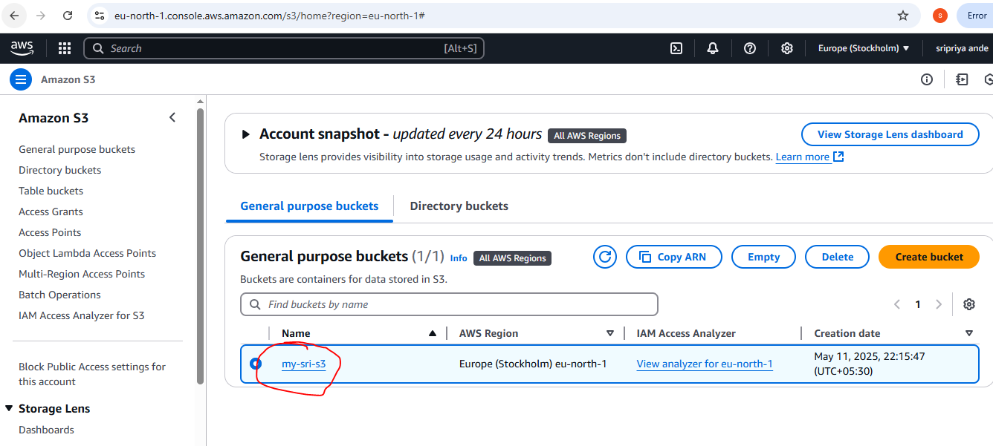

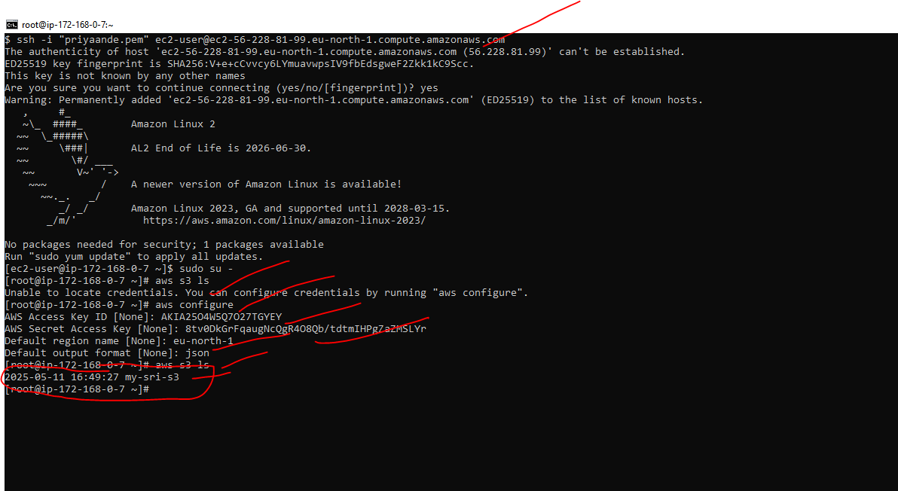

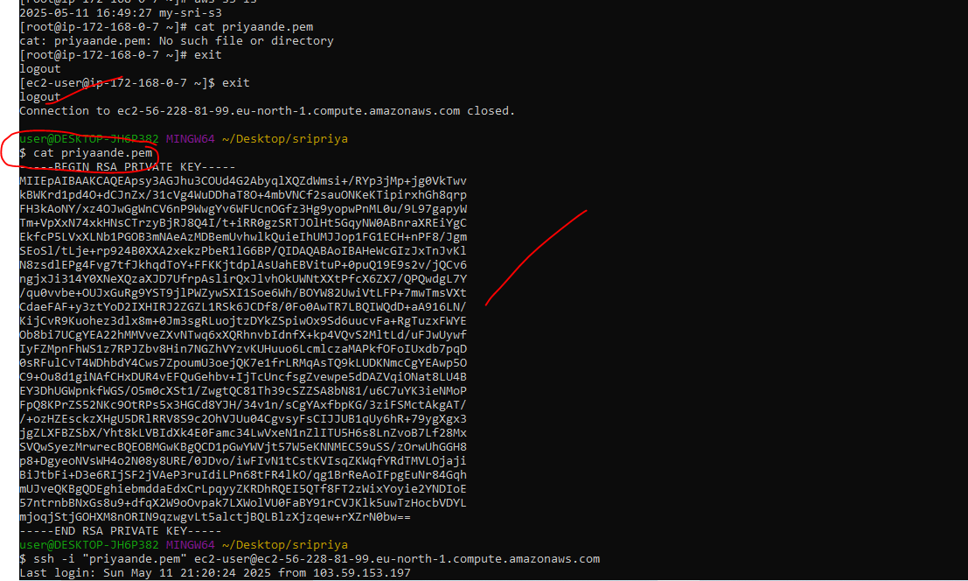

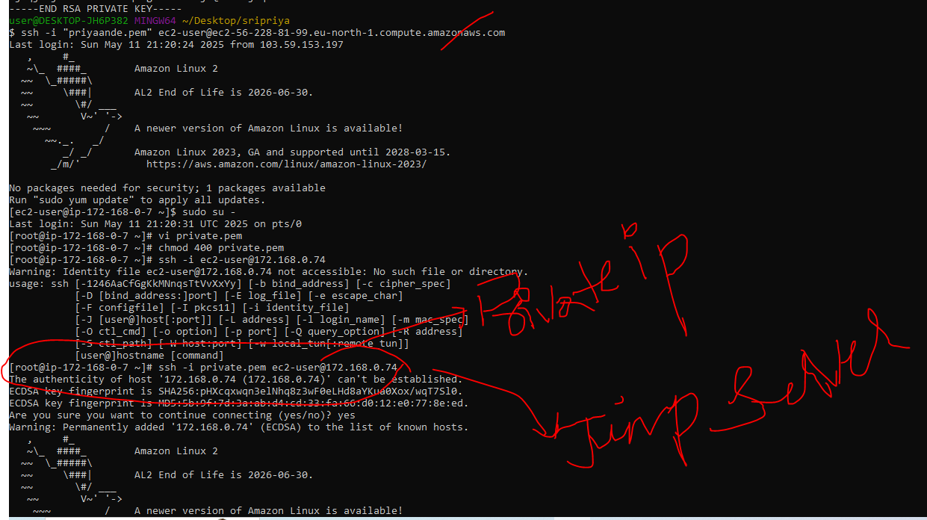

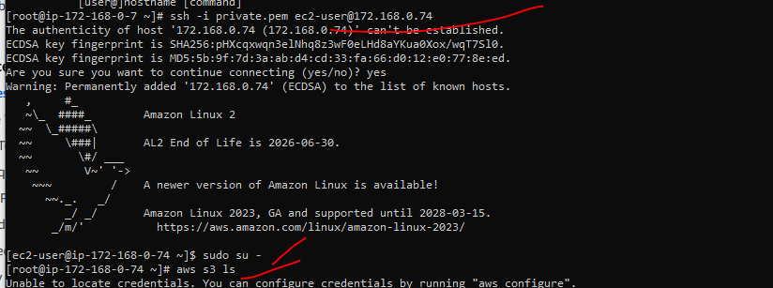

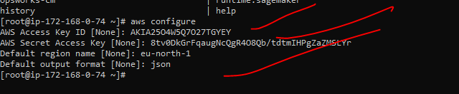

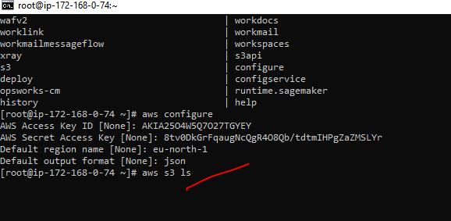

Now creating endponit for this S3 and attach endpoint to the RT of Private ec2.

Go to aws -->-vpc--->end ponits

Create endpoints--->name (s3-endponits)

Choose any service categatoty(aws service)

Choose s3

Choose gateway

Vpc(default)

RT(private)

Policy(full access)

Create endpoints

Now in git bash we get connection

With help of end point we can commnicate without any internet connection to check s3 securely

